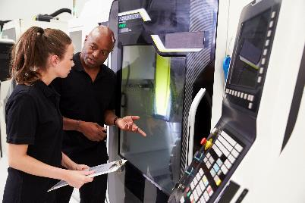
Engaging Employers in Scenario Development
This template offers a format for requesting scenario examples from industry partners to support employability skills instruction. Use as appropriate for local program enhancement. It will be important to share with companies how the scenarios they contribute will be used to enhance students’ employability skills in your course(s).

Company Information
- Company Name
- Your Name and Position
- May we include your company name and logo when sharing your scenario in _____ courses at _____ Community College?
- Yes – company name and logo can be used
- Yes – company name can be shared
- No – neither company name nor logo can be shared

Employability Skills to be Emphasized
Please identify the employability skills that are emphasized in the scenario you are submitting. Check all skills that apply. To add skills to the list, please use the “Other skills” box below.
- Teamwork (working with others to complete a collaborative, goal-driven effort)
- Problem-Solving (using critical-thinking to handle and resolve unforeseen circumstances)
- Verbal Communications (listen, speak, and present to peers, superiors, and customers)
- Written Communications (read and professionally express oneself in business reports, correspondence, etc.)
- Dependability/Work Ethic (deliver work on time reliably, confidentially, and ethically, even under duress)
- Planning and Organizing (efficiently tackle tasks in light of company goals and resources, legal restrictions, schedules, quality, safety, etc.)
- Other skills emphasized:

Scenario Example
Please type your workplace scenario in the space provided below.
Here is an example:
An oil rig in the Gulf of Mexico needs real-time inspection of its pilings and decking. Technicians, Technologists, and Engineers working for AmBilo Energy Co. are tasked with building and demonstrating a quadcopter drone with a high-def camera to carry out such a task. To replicate the prototype at other facilities, the regional supervisor asks the team to keep a logbook and deliver a short presentation that describes the procurement, development, and test results for the project.

Your Scenario

Company’s Desired Outcome for the Scenario

Related Mission Statement or Company Value
If the scenario you submit relates directly to a company mission or value statement, please provide it below and explain how employees should use the mission or value statement to guide their decision-making.

Key Information to Add:
- Instructions for submitting scenario and company logo (if applicable).
- Your contact information if the submitter has questions.
- Note of thanks for taking time to provide valuable input that will make your course more relevant to students and better prepare them for the workplace.

