NC-NET Employability Skills Resource Toolkit
Module 3: Integrity and Professionalism
Overview 2
Presentation Materials 3
Teaching Resources 7
Activity: Developing Professionalism 8
Activity: Professional Image 10
Activity: Honesty and Integrity 16
Activity: Giving and Receiving Feedback (constructive criticism) 19
Activity: Professional Code of Ethics 26
Activity: Putting it All Together 31
Assessment Tools/Strategies 36
Rubrics for Instructor Assessment 37
Rubric for Self-Assessing Integrity and Professionalism Skills 38
Rubric for Giving and Receiving Feedback 40
Videos and Weblinks 42
Videos 42
Weblinks 42


Overview
Integrity and professionalism are essential for a motivated and productive workplace. Whether aware of it or not, every person is evaluated continually. The image we project leads to judgments by others on our capabilities. Behaviors that are perceived as unprofessional or dishonest may ruin any opportunity to do business with a particular individual.
In this module we will review aspects of integrity and professionalism including:
- Developing Professionalism
- Professional Image
- Honesty and Integrity
- Giving and Receiving Feedback (constructive criticism)
- Professional Code of Ethics
- Putting It All Together
This module provides:
- Instructor Presentation Materials—A set of slides to help organize the topics for discussion and provide talking points to introduce the activities
- Classroom Activities—A set of activities from which to choose, requiring minimal material and preparations, to address facets of integrity and professionalism.
- Assessment Tools—Rubrics for use by both instructor and student to assist in gauging progress throughout the course
- Videos and Links—A collection of linked resources to help the user take advantage of the abundance of electronic media available to both instructor and student
Presentation Materials
 | SLIDE | TEACHER NOTES
1
2 | 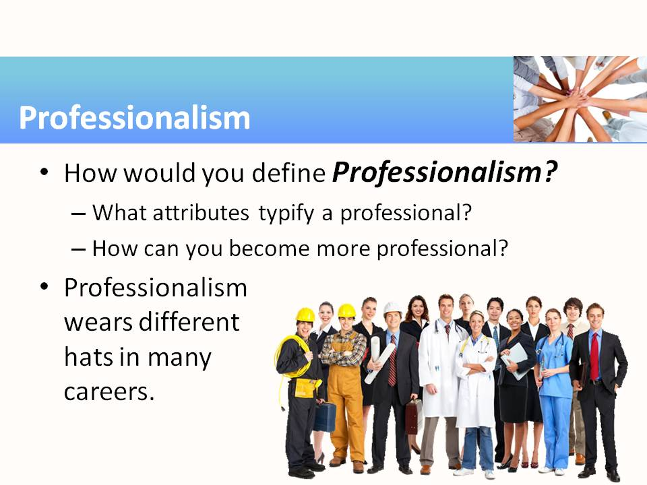 | - Almost everyone will agree that integrity and professionalism are positive attributes and are important for successful careers. But what exactly is professionalism? Are you born with it or is it something you must learn or cultivate?  - The online article referenced in the first activity is a great starter for this discussion and this module’s activities:  http://www.mindtools.com/pages/article/professionalism.htm
3 | 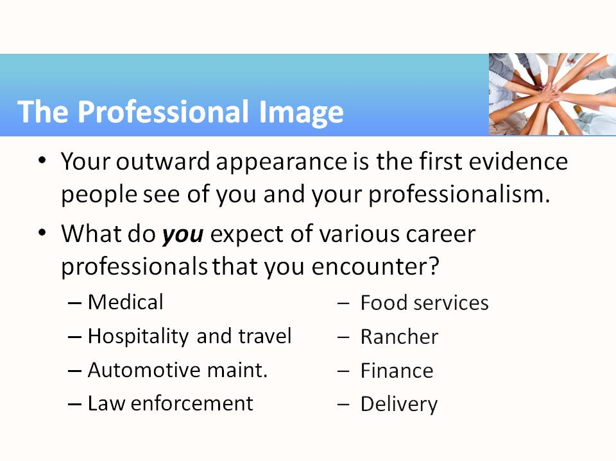 | - Although some careers do not require professional attire or uniforms, and some even expect you to get dirty while working, most of us would immediately question the authenticity or professionalism of any worker who presented himself dressed sloppily or uncleanly.
4 | 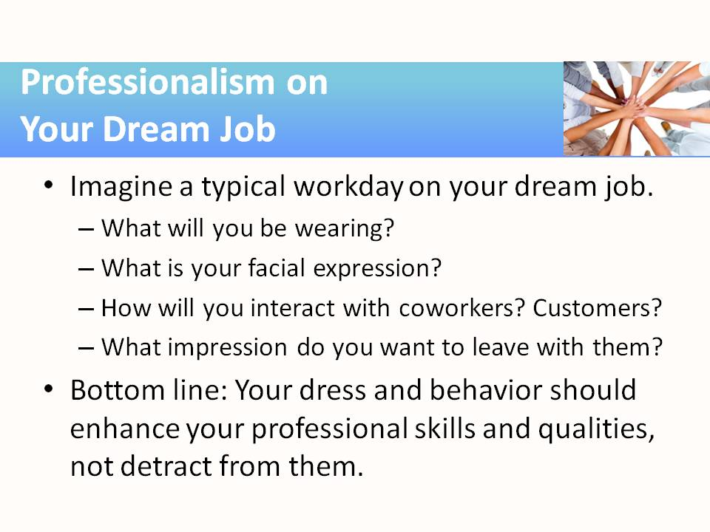 | - Consider browsing together as a class some of the links provided in the module activity concerning proper attire, interviewing skills, and so forth.
5 | 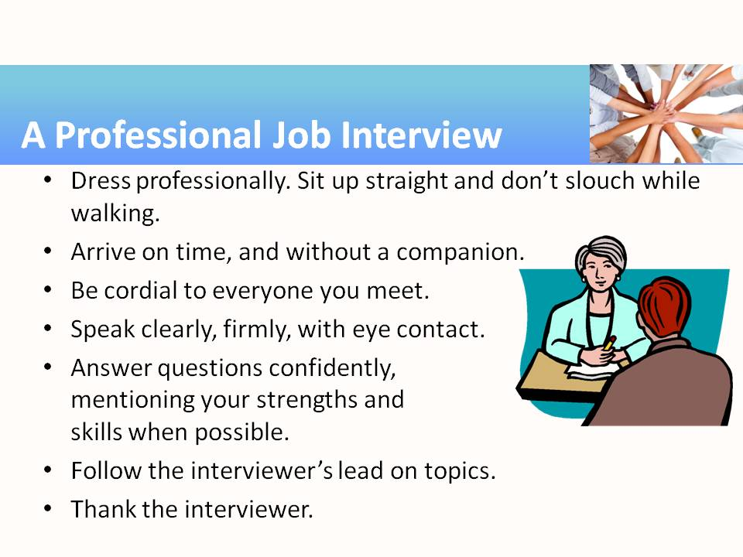 | - These are some highlights of the complete list of Interviewing Tips included in the activity.
6 | 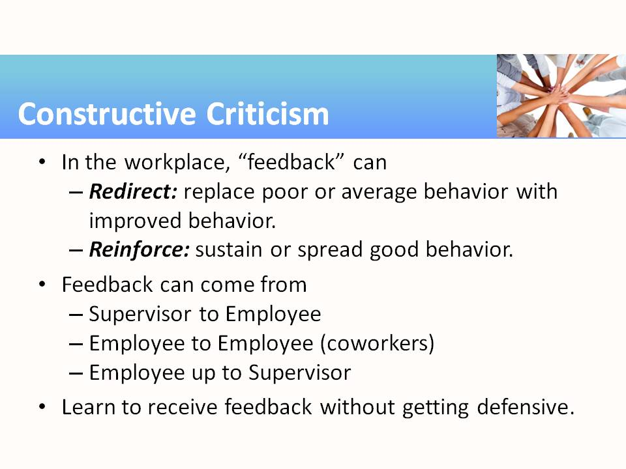 | - This module activity is focused on feedback related to job or workplace performance. Try to keep the discussion about employees and the workplace, rather than relationships related to marriage, family, and friends.
7 | 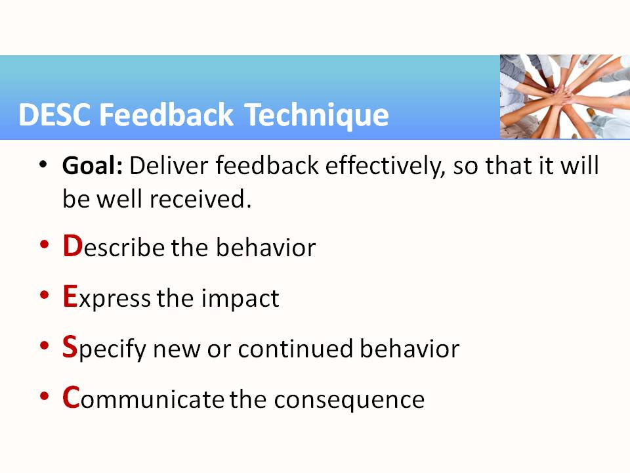 | - The activity handout summarizes the DESC technique for giving others feedback, including some tips for making DESC even more effective.  - Students can role-play the provided scenarios to practice these techniques.
8 | 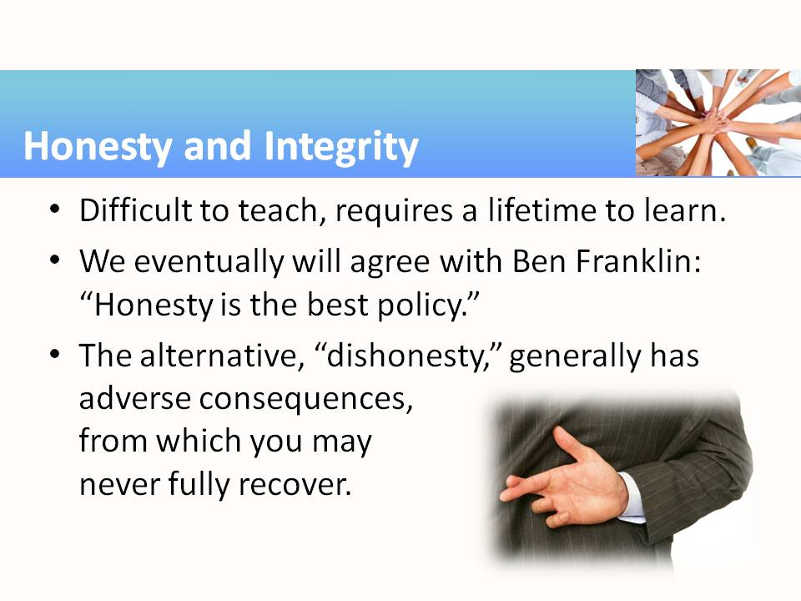 | - The activity on honesty and integrity will be challenging, probably because these notions have become so fluid in today’s society. Although the social message clearly encourages dishonesty, or at least deception, everyone would prefer to have honest dealings, both in their business and personal lives.  - Discuss deception:  - Misleading rather than explicitly lying  - Allowing others to come to the wrong conclusions, often motivated by benefit to yourself or the company  - Is this the same as lying?  - What are the consequences of deceiving or lying to others in our personal lives? In business?
9 | 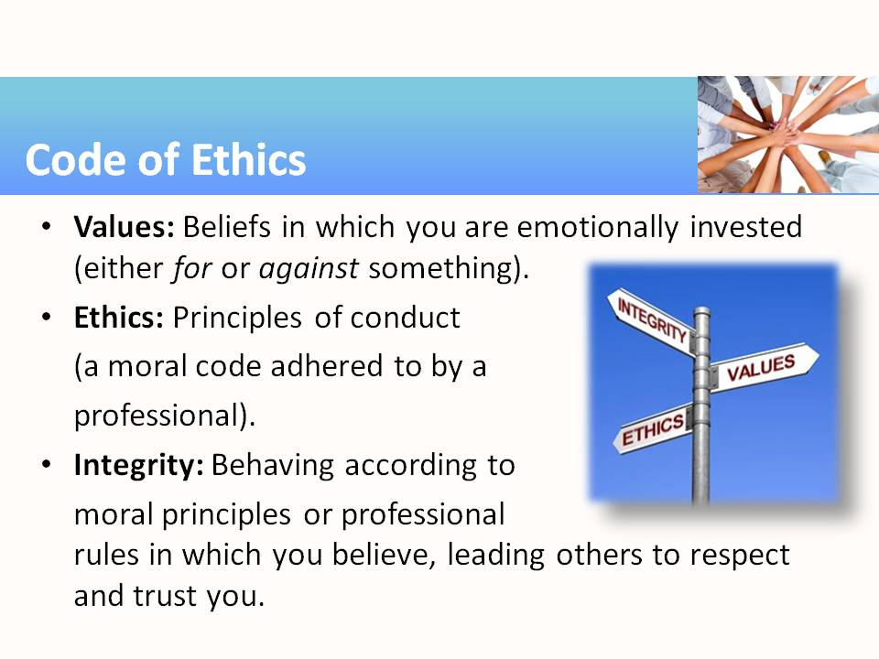 | - Many fields of employment will expect everyone to operate under some set of rules of acceptable behavior. Ask students: Where did those rules originate? (Suggested answer: In general, they come from the values of the company workers, the conduct that is expected of the workers [i.e., ethics], and from rules and norms of morality practiced by the community as a whole [i.e., the integrity of the workers]. So, on the next slide we’ll see how these ethics are often codified into documents.)
10 | 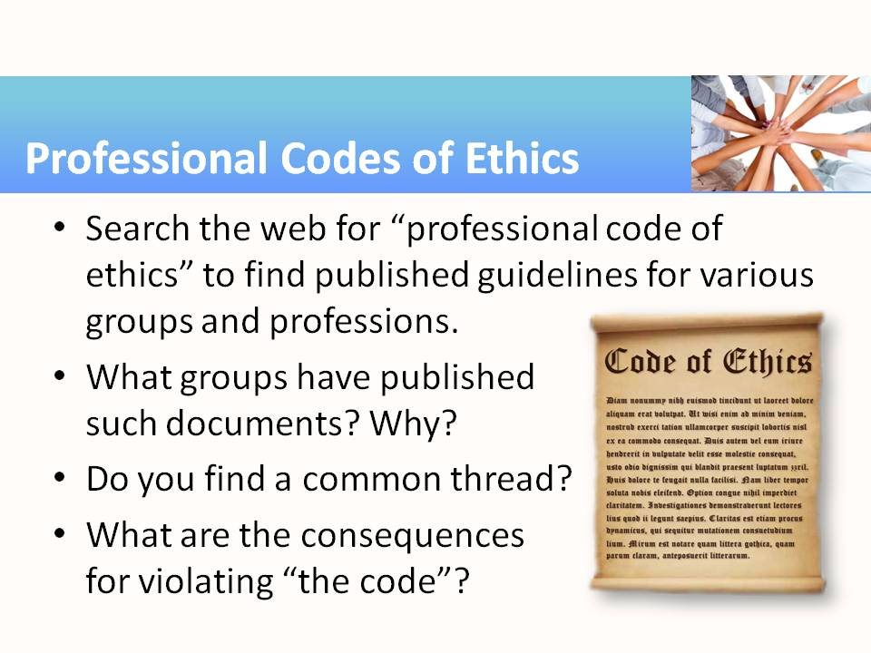 | - In many professions in each of the career clusters there is a well-known set of codes to which everyone agrees to adhere. (See the list of example codes included with the activity.) Students should locate an example or two of those and discuss them, as directed in the module activity.  - Pose the question (perhaps selecting a well-known example in your career area): Why do such published codes even exist?
11 | 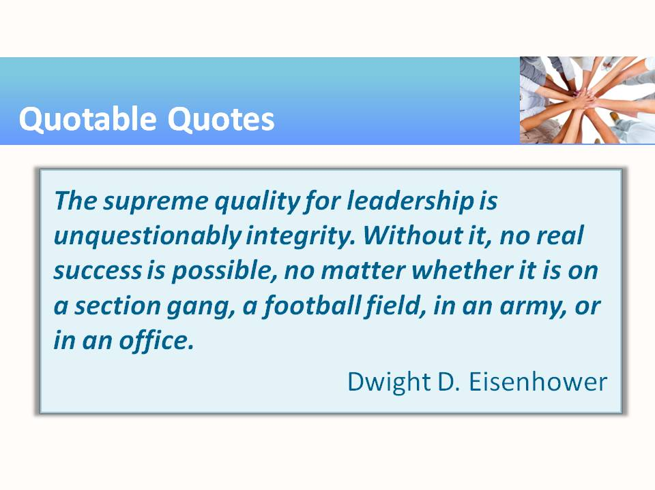 | - http://www.brainyquote.com/quotes/quotes/d/dwightdei109026.html
Teaching Resources
Activities
The following activities are examples of activities that can be completed in class to emphasize, teach, and help students practice integrity and professionalism. The activities found in this resource can be used “as-is” or they can be tailored to fit a specific course. Suggestions for adaptation precede each activity with examples from several different subject areas/career pathways. The suggested modifications provide instructors with ideas for adapting the activity to fit content they are already teaching. Modifying the activities allows employability skills to be infused in subject-area content more easily.
Activity: Developing Professionalism
Instructor Preparation
Everyone talks about the importance of being professional in the workplace. But what exactly is professionalism? Professionalism is sometimes difficult to define because it is not one single characteristic but a blending of many. The object of this lesson is to have students describe professionalism and all that it encompasses. They will discuss what professionalism looks like in different careers and what characteristics remain the same across all careers. Students will then examine each identified characteristic of professionalism and list at least two things they can do to grow or improve in each area.
For example, all careers have the expectation that workers will be honest and have integrity. Some careers have higher requirements for confidentiality than others, such as medical professionals, lawyers, and those working in security jobs. All jobs require skill and knowledge, but some require more specialized knowledge and skills. If the class has done activities from other employability modules, this module will build upon concepts learned. For example, if the activity for goal setting from the Initiative and Dependability module was used, students might use what they learned about SMART goals to create their plan for increasing their degree of professionalism. Additionally, the good communication skills described in Interpersonal Skills and Teamwork contribute to one’s image as a professional.
Objectives
Students will:
- Describe attributes that are encompassed by the term professionalism.
- Create a plan for attaining skills and knowledge in these areas.
Materials
- Computers with Internet access
Activity Guidelines
Have students do the following:
- Read the article “Professionalism: Developing This Vital Characteristic” (http://www.mindtools.com/pages/article/professionalism.htm) and list the attributes that constitute professionalism.
- Optional: Research other definitions of professionalism available on the Internet and list additional characteristics that are commonly mentioned. Add these characteristics to the list if they are not synonymous with the ones listed in the MindTools article.
- Have students work in small groups to create definitions for the listed characteristics of professionalism, with examples for each.
- Ask students, working individually, to rate themselves in each of the categories. Have them identify areas where they think they have the greatest strengths and weaknesses.
- Guide students in creating a plan for developing specialized knowledge, competency, honesty and integrity, accountability, self-regulation, and image.
Group Reflection Questions
- Why is it important to be professional in all aspects of your work life?
- What impression would you have if you walked into a doctor’s or lawyer’s office and staff were gossiping about an earlier patient or client? Would you trust them to maintain your privacy?
- If working on a job where you know you will get filthy each day, is it professional to come to work in the grubby clothes worn the day before? (Clothing has not been laundered.)
Activity: Professional Image
Instructor Preparation
This lesson may seem elementary to the instructor and some students because it is about dressing appropriately and projecting a professional image. However, human resources personnel complain that workers and job applicants show up dressed entirely inappropriately for the interview or job. Why is this? “Appropriate dress” is an ambiguous term for many, particularly since it varies from situation to situation and is influenced by social customs, geography, and propriety. Business casual on the east coast is different from business casual on the west coast. Startup casual is different from business casual. The general rule is to err on the side of being overdressed rather than dressing too casually.
This lesson includes two parts: dress and personal appearance and making a good first impression at a job interview. Dress and personal appearance are key elements of making a good first impression, but communication skills, manners, self-control, and posture all contribute to that first impression.
Objectives
Students will:
- Describe appropriate dress for various work environments.
- Suggest ways to expand a limited wardrobe.
- Discuss appropriate personal appearance and hygiene and the “first impression” it might portray to others.
Materials
- Computers with Internet connection
- Handout—Interviewing Tips
- Handout—Weblinks list
Activity Guidelines
Part 1
- Begin this activity by asking students how they would expect people in various careers to dress: a doctor, a mechanic, a tour guide, a hostess in an upscale restaurant, a rancher, a lumberjack, a pilot, and so forth. Ask if they can think of attire that portrays a brand image, for example, the brown uniforms worn by UPS delivery persons or military uniforms.
- Then ask students if they have ever been somewhere where one of the employees was wearing something that did not match the image they expected. Maybe it was a pastor with full tattoo sleeves, or an obese manager at a fitness center, or a janitor in slacks and button down shirt and loafers. What was their reaction?
- Discuss how a professional image might differ with different careers or situations. Then have students go online and research dress codes for business. (You might wish to ask business partners or advisors for your program to provide copies of the dress code for their company.) Students should focus on dressing for a future career. If students are finding it difficult to locate dress codes, they might look at clothing store catalogs catering to business attire and/or uniform catalogs for careers where workers wear uniforms. Have them select clothes that would meet the dress standards for the chosen career, but would accommodate their body type and personal sense of style. Have them print a copy that they can share with the class. If time permits, price the outfit(s) chosen. Have students look for ways to extend the wardrobe in a cost-effective manner.
- Alert students to the existence of other personal appearance regulations governing such things as exotic hair styles, tattoos, and piercings; wearing of fragrances and makeup; and use of personal electronics. Be sure they understand that even though they have the right to freedom of expression through their personal appearance, companies have the right to determine what image an employee portrays to the public during work hours.
- Optional: The instructor could come to class dressed entirely different from his/her normal dress code. Ask the students to discuss how that particular look would have impacted their reaction when they walked into class the first day. (You might choose a similar style of dress, but wear clothes that don’t fit properly, are wrinkled or stained, or are otherwise inappropriate, or dress appropriately for a career outside education, or outside the career technology area in which you teach.
Part 2
- Discuss with students the idea that when they are looking for a job, it is vitally important to make a good first impression by appearing competent and professional. Ask students to describe interviews that they may have already had. In hindsight, what do they think they did well and in what areas do they think they could improve?
- Have students use Internet resources to research “first impressions at job interviews.” Have them create a list of tips found in each source. Remind them to include the URL where the tips were found. Then have the class make a master list. A sample list of websites offering interviewing tips is included at the end of this document.
Group Reflection Questions
Have students discuss the following:
- Think about your dream job. Describe how you would prepare for the interview to give the best professional image. Then assume you have gotten the dream job. Picture yourself at work. What will you be doing and wearing? How will you act? What kinds of people will you come in contact with on any given day? What impression will those people take away from the encounter? What can you do now to prepare for these scenarios?
- Why do you think it is so difficult to overcome a bad first impression? How many of you may have had a poor first impression of someone and after getting to know the person decided your first impression was wrong? How long did it take before you changed your mind?
- Many sites will tell you when dressing for work, stick to the classics. How would you describe classic style?
- What are the advantages and disadvantages of wearing a work uniform?
- If someone announces that a VIP is coming to your class in 10 minutes, what are three things you could do in that time to get ready to make a good first impression? What would you have worn or done differently if you had been told the day before?
Handout—Weblinks for Professional Image and Making a Good First Impression
Dress Codes
- The 10 Commandments of Dressing for Work http://www.cnn.com/2011/09/16/living/workplace-professional-dress-cb: This Career Builder article provides guidelines for appropriate dress for work.
- Dress Code
http://humanresources.about.com/od/glossaryd/g/work_dress_code.htm
Human Resources article at About.com on dress codes. There are numerous links to different dress codes such as business casual for those who interact with customers, for those who work in manufacturing, etc.
- Professional Image in the Workplace: Is it Important? Image Matters http://www.google.com/url?sa=t&rct=j&q=&esrc=s&source=web&cd=6&cad=rja&ved=0CEIQFjAF&url=http%3A%2F%2Fwww.soa.org%2Flibrary%2Fnewsletters%2Fstepping-stone%2F2006%2Fapril%2Fssn-2006-iss22-costello.aspx&ei=pJWSUaeTMIjtqwGMtoC4DQ&usg=AFQjCNFkq9riLA-W_NrZaUi1yauNB6FE-g: This is an article on the importance of image in the workplace and how it might influence promotions as well as perceived usefulness to a company.
- Dress code
http://en.wikipedia.org/wiki/Dress_code_%28Western%29
This Wikipedia article shows the evolution of today’s modern dress code. It contains an exploration of appropriate attire for different social occasions.
Managing First Impressions/Interviewing Skills
- Making a Great First Impression
http://www.mindtools.com/CommSkll/FirstImpressions.htm
This MindTools article describes how to make a good first impression.
- Managing First Impressions at Interviews: http://sciencecareers.sciencemag.org/career_magazine/previous_issues/articles/1999_03_12/nodoi.13642567244796414228
- Dress Appropriately for Interviews: http://career-advice.monster.com/job-interview/Interview-Appearance/Appropriate-Interview-Dress/article.aspx
Career advice from Monster regarding interviews.
- Make a Great First Impression
http://career-advice.monster.com/job-interview/interview-preparation/make-a-great-first-impression/article.aspx
More career advice from Monster concerning interviews
- Interviewing tips from CareerBuilder
http://www.careerbuilder.com/Article/CB-409-Getting-Hired-How-to-Conquer-the-First-Impression/
- What to Wear to a Job Interview
http://jobsearch.about.com/b/2013/03/20/what-to-wear-to-a-job-interview.htm
This article discusses how to dress for an interview. There are numerous links for specific types of job interviews.
Handout—Interviewing Tips
In a job interview, one naturally wants to do all that you can to make a good impression. Here are some important reminders:
1. Dress neatly, wearing clothing that suits the job you want.
2. Be on time. Tardiness signals to the employer that you are not really interested in the job or that you might show up late for work.
3. Arrive alone. There is no need for anyone to go with you to an interview. You must do it on your own.
4. Greet the receptionist or the person who will introduce you to the interviewer. Be pleasant. Say your name clearly, and tell this person the name of the interviewer if you know it. Be sure to name the job for which you are applying.
5. Wait patiently if the interviewer is not ready for you. If you talk, speak clearly. You may want to sit quietly and read the materials in your personal information folder until you are called to the interview.
6. If it seems appropriate, shake hands when you meet the interviewer. Use a firm handshake but not an overpowering one. Wait for the interviewer to ask you to sit down.
7. Maintain eye contact with the interviewer. This is considered a sign of honesty and self-confidence. For this reason, do not wear sunglasses during an interview.
8. Control any nervous behavior. Tapping your foot or clicking a ballpoint pen, for example, may annoy and distract the interviewer. Never chew gum during an interview.
9. Do not smoke.
10. Choose your words carefully and avoid slang or other special expressions that the interviewer may dislike or misunderstand.
11. Sit up straight in your chair. If your posture is good, the interviewer will perceive you as alert and interested in what is happening.
12. Talk about what you do well. Often you will find that you can answer a question by mentioning certain talents, interests, or skills. Mention test scores only if you are asked to do so. If you have done poorly on a test, avoid making excuses for your performance.
13. Follow the interviewer’s lead during the course of the interview. Stick to the point. The interviewer is interested in experiences and attitudes that might affect your performance on the job. There is no need to talk about details of your personal life.
14. Be calm. Try not to show disappointment or anger if you are not hired, or if the interviewer does not decide immediately. He or she may have to see other applicants before deciding.
15. Say “thank you” and arrange to call back if necessary. Even if you have not been offered the job, or if no decision has been made, tell the interviewer you are interested in the position. Ask whether you can call back at a certain time to find out about the decision.
16. After the interview, write a note thanking the interviewer for his or her time.
Activity: Honesty and Integrity
Instructor Preparation
Honesty and integrity are difficult to teach. While we learned that we should tell the truth at an early age, the world isn’t all black or white. We find ourselves justifying little white lies to protect someone’s feelings or to keep us out of trouble. Once you start down the path of little white lies, it becomes easier and easier to justify stretching the truth or rationalizing our actions.
Students need to realize the consequences of dishonest behavior. Once someone has been caught in a lie or other dishonest act, the people around that person lose respect for them and may no longer trust that person in the future. It takes a long time to earn back trust and respect. In the workplace, dishonesty can result in losing your job. Have your students discuss why employers need employees who are honest and have integrity.
What are some ways an instructor might use to teach students about honesty and integrity? Remind students of childhood stories and fables they may have heard when they were being taught to be honest. If any students want to work in education, and especially early childhood education, have them make a reading list of stories such as “The Little Boy Who Cried Wolf,” “Pinocchio,” and appropriate fables. Then ask them to prepare a series of lesson plans for teaching children about honesty.
Students in communications might be interested in viewing video clips on the subject of honesty and analyzing the message of each video, the manner in which it was conveyed, and whether the message could have been conveyed in a more appealing way. They could create a storyboard for shooting their own video on honesty and, if time allows, produce the video. Two videos on honesty are listed in the weblinks handout. One is a black and white teaching film from the 1950s, and the other is a more recent lecture by Frances Tuttle. These could be used as the films to be analyzed.
Provide case studies in which businesses were sued for falsely representing their products or services. There always seem to be stories in the news about people who have cheated on their taxes, used substandard materials and pocketed the savings, used public property for private gain, or accepted bribes or payoffs. Present the facts of a recent incident and have students identify the dishonest behaviors and the consequences not only for the dishonest person, but for all around him or her.
Point out that some professions have a stereotyped reputation for dishonesty—used car salesmen and cleaning staff at hotels that get blamed for stealing, for example. Discuss why we have stereotypes in the first place. Discuss whether or not the stereotypes are justified. The reverse is also true. Some professions have the reputation of being particularly honest such as doctors, preachers, and teachers. Discuss why we may be hurt or disillusioned when a person in one of these careers is found to be cheating on his spouse, embezzling money from her place of business or a community organization, or has committed some other crime or dishonest practice.
Objectives
Students will:
- Define honesty and integrity.
- Discuss how honesty and integrity might be tested in the workplace.
Materials
- Computer with Internet connection
Activity Guidelines
Discuss some of the questions posed in the Instructor Preparation section above.
- Ask students if they can remember their first lie and the consequences that resulted. Then ask them if they remember how they felt the first time they discovered that someone had lied to them or cheated them in some way.
- Allow a few minutes for students to discuss the extent to which the following statements would apply to them in the workplace. (Feel free to create similar statements applying to the classroom.)
  - If I had access to the internet at my workplace, I would only use it for work and never for personal reasons.
  - My productivity would be the same regardless of whether I am being supervised or not.
  - If I were applying for a job, I would be completely truthful on my résumé.
  - If one of my co-workers consistently took extra time at lunch and left work early, I would report it to my supervisor.
  - If I heard malicious gossip about a co-worker, I would keep it to myself.
  - I would never use office supplies (pens, paper, etc.) for personal use.
Activity 1
Use this activity to demonstrate how people get caught up in a tangle of lies to the point they can’t distinguish the truth from a lie. It is fairly quick and gives students a chance to stand up and move around.
- Have students form a circle. If your class is large, have them form a couple of smaller circles.
- Choose a topic that everyone is familiar with and let students know what it is.
- Have the first student start a story about that topic. They are to make up two sentences. One is the truth and the other is a lie. They repeat their two sentences of the story to the circle. When they repeat the sentence that is a lie, they wink broadly for all to see (or roll their eyes, or make some other gesture) so the group knows which is the lie.
- The next student repeats the first person’s story, again making the agreed upon gesture when the lie is repeated and adds two more sentences to the story, one true and the other not. They make the same gesture when they repeat the lie they are adding to the story.
- Continue to go around the circle with each student adding a true sentence and a lie to the story until students begin confusing the true statements and the lies.
- You can have your students play the game more than once to ensure everyone gets a chance to participate.
- Wrap up the activity by asking students questions to see if they had difficulty remembering which statements were the truth and which were the lies.
Note: This activity also demonstrates how gossip can be passed around the office. Lies are embellished with each telling, and situations get blown out of proportion.
(Optional) Activity 2:
This is another activity that demonstrates a point and gets students up and moving.
- Have four students stand in a circle. Have the students opposite one another grasp right hands. Then have them grasp a different student’s left hand resulting in a tangle of arms. Each pair represents a lie or dishonest act.
- Direct students to untangle themselves and form a circle without releasing another students hand if at all possible. Students may step over or duck under student linkages as needed.
- Next, add another pair of students to the mix, again grasping the right hand of the person directly across from them and left hand with someone else. This new pair represents another lie or dishonest act.
- Again, have students detangle themselves to form a circle without breaking linkages if possible.
- Discuss how the deeper we become entangled in a lie, the more difficult it is to repair a situation.
Group Reflection Questions
Discuss the following questions as a class.
- What might be the problem with comparing your level of honesty with someone else’s?
- What insights into honesty and integrity in general, and your own honesty and integrity in particular, did you gain by working through this lesson?
- Give examples from current movies or TV shows that describe ethical dilemmas and where characters did or did not exhibit honesty and integrity.
- Provide the following quotes and/or others from The Power of Truth website at http://www.thepoweroftruth.com/truth_quotes.html and have students discuss what they mean:
- "Oh, what a tangled web we weave when first we practice to deceive." – Sir Walter Scott
- “No man has a good enough memory to make a successful liar.” – Abraham Lincoln
- “Integrity is doing the right thing, even if nobody is watching.” – unknown author
- “Integrity is telling myself the Truth. And Honesty is telling the Truth to other people.”
– Spencer Johnson
Activity: Giving and Receiving Feedback (constructive criticism)
Instructor Preparation
One of the most important areas of human relations is the ability of people to give and receive criticism without that criticism negatively impacting relationships and job performance. Young adults are particularly sensitive to criticism, but they are more apt to criticize without thinking of the consequences.
Discuss with students the fact that criticism is a fact of life and that just as we are continually evaluating others around us, we are being observed by others and they are evaluating us. The evaluations we make may be based on the appearance of others, their behavior, the clothes they wear, their political views, how they drive, what they drive, or many other details. (The evaluation may be fair or unfair, and may be hastily made.) While we may never verbalize our criticisms, we often express them through our actions, facial expressions, gestures, and behavior.
Point out that no employee in any business is exempt from criticism. The scenarios used for the role-plays come from the fast food industry, health care, construction, and business. Scenarios in other fields can be easily created.
Be aware that in the business world the terms criticism and constructive criticism are being replaced by the term feedback, which does not have strongly negative associations and can be used for both positive and negative evaluations.
In working through this activity, explain that the two main purposes of workplace feedback are to redirect and reinforce employee behaviors. In redirection, the focus is to identify poor or average behavior and change and improve it. In reinforcement, the focus is to sustain good behaviors.
It is generally thought that feedback comes from the top down in an organization, but in fact feedback can come from supervisor to employee, employee to employee, and even from employee to supervisor. In many of the most productive work environments, feedback is regularly requested from others at all position levels, and there is open dialog between giver and receiver. This environment does not happen overnight. It must be built on trust, honesty, and a sincere desire to grow and prosper in the workplace and to meet individual as well as corporate goals.
Objectives
Students will:
- Define constructive criticism and explain how it compares to feedback.
- Give reasons why both giving and receiving feedback (criticism) can be difficult.
- Role-play a work-related evaluation situation.
- Suggest ways to make feedback productive.
Materials
- Handout—The DESC Feedback Model
- Handout—Characteristics of Effective Feedback
- Handout—Receiving Feedback
- Scenarios for Role Play
- Handout—Observation Sheet for Scenario Role Play
Activity Guidelines
- Point out that this activity is focused on feedback related to job performance. Then have students discuss the following questions:
- What are some reasons an employee might receive criticism on the job?
- What might be the consequences of poor job performance?
- What approaches might be used to facilitate the evaluation interview?
- After discussing approaches that might be used, give students copies of the student handouts: The DESC Feedback Model, Receiving Feedback, and Characteristics of Effective Feedback. The DESC model for giving feedback is a technique that is often taught to business executives and used for providing feedback. Receiving Feedback gives students tips for accepting feedback in an open and honest manner so they can grow from it. Characteristics of Effective Feedback provides pointers to ensure feedback is given in a positive manner that will be helpful to the receiver. Give students a chance to review each document before having them role-play the scenarios.
- Students will work in groups of three to role-play various situations involving giving and receiving feedback. The third person in the group will be the observer. There are four situations from which to choose. Each student should be given the opportunity to give, receive, and observe in at least one situation. Note: Use the scenarios provided or have students suggest scenarios from their work experience.
Group Reflection Questions
- How can the way you “give” and “take” feedback affect your relations with an employer? With coworkers? Friends? Family?
- Why is the evaluation interview a delicate encounter for both the supervisor and the employee?
- Not everyone is good at providing feedback. Sometimes problems occur and the first person to cross paths with the supervisor might be blamed and berated for the problem regardless of whether they were in a position to do anything about it. Sometimes managers store up little problems until they reach the one that tips the scale and then dumps everything on an employee at once. Others may have a tantrum. Still others may give vague or indecisive feedback leaving the receiver unsure if they are doing well or not. Discuss various ineffective feedback types and discuss ways of handling them.
Handout—The DESC Feedback Technique
Most people have to learn to provide effective feedback. Our natural tendencies are to either understate the issue and come across as too soft or passive, or to come on too strong and appear aggressive. Feedback should be provided in an assertive manner expressing our own observations, concerns, needs and opinions, while respecting the rights and needs of the person to whom we are providing the feedback.
The DESC technique is a used to give feedback in an assertive manner. The four steps of the DESC Feedback technique include the following. (Note: This model can be used whether the feedback is positive or negative.)
1. Describe the behavior
2. Express the impact
3. Specify new or continued behavior
4. Communicate the consequence. (Note: Step 4 is not always possible or necessary)
Think about how this technique might work in the following situation:
You observe Jerri loudly criticizing Jeff, one of the paralegals “. . . how can you be so stupid? This report has so many errors, a 12-year old could have done better. Where did get your degree anyway? A bubble gum machine?” You feel embarrassed for Jeff, and you are highly disappointed by Jerri’s manner of communicating her displeasure to him.
Possible DESC Feedback might go something like this:
- Describe the behavior
“Jerri, when you criticize Jeff publicly and use words that are demeaning …”
- Express the impact
“…I feel embarrassed for him, and disappointed that you believe this approach would be helpful.”
- Specify new or continued behavior
“I would like you to give critical feedback in private, not call others names, and deliver it in a constructive, professional manner.”

- Communicate the Consequence. (Note: Step 4 is not always possible or necessary)
“or you may find that others will lose respect for you.”
So what makes DESC Feedback more effective?
- Use “I statements” – it says “I have the problem and I want to fix it.”
- Be brief–avoid repetition or “stockpiling” (you’ve also done this, this, and this wrong).
- Use non-judgmental descriptions of behavior (“you criticized Jeff publicly” instead of “you are rude and uncaring”).
- Avoid ascribing motives to behavior–we can’t know why people act the way they do.
- Avoid absolutes and exaggerations (always, never, the absolute worst).
- Make sure your body language and voice tone support your verbal assertive message (a twist of your lip or rolling your eyes can change the message completely).
Handout—Characteristics of Effective Feedback
Before giving any feedback, make sure that it is given to improve the situation or performance. Remember that effective feedback is:
- Clearly communicated.
- Specific rather than general. It tells the person exactly what the problem is and doesn’t leave them wondering what something vague, such as “You need to improve your unprofessional behavior,” means.
- Focused on behavior rather than the person.
- Focused on helping rather than hurting.
- Focused on behavior that the recipient can do something about.
- Focused on one or two incidents at most, not a laundry list of items. It is much easier to discuss one incident or poor performance rather than a year’s worth of poor performance.
- Focused on observed behavior.
- Timely, that is, shared as soon as possible after an incident is observed and no longer than a week after the incident. If an incident is highly emotional, wait until everyone has calmed down and regained self-control so nothing might be said that will be regretted later.
- Provides opportunities for further discussion.
- Provides clear suggestions about improvement.
- Provides for redirection (identifies behaviors and performance that do not contribute to individual, group, and organizational goals and helps the receiver develop alternate strategies) and reinforcement (identifies behaviors and performance that is beneficial and contributes to individual, group, and organization goals, and encourages the receiver to repeat and develop those actions).
- Provided in private, not in front of others.
- Directed to the future.
- Goal oriented
- Multidirectional: both the provider and receiver actively listen to one another’s issues and work together to solve the problem(s).
- Ongoing, not a once-a-year dump of issues.
Above all, feedback should be viewed as an opportunity to learn and improve in a way that benefits all involved.
Handout—Receiving Feedback
No one likes to be on the receiving end of criticism, even when gently given. Our first reaction is always defensive. We must train ourselves to listen carefully and actively to evaluate the feedback as we receive it and then to act on it. No matter how poorly the feedback is presented, we must try to understand why the presenter feels as they do and keep the feedback received in perspective.
Don’t fall into the trap of disregarding any feedback given in an inappropriate or rude manner as not worth considering. Instead, by active listening and asking questions, help the person giving the feedback become better at it.
A four-step method for receiving feedback follows:
Step 1: Ask for detailed information about the problem and for specific examples to be sure you understand the reason for the feedback, whether bad or good. It is just as difficult to interpret a “good job, keep it up” comment as it is to interpret “you are a screw-up and if you don’t improve your work, you will be out of here.” Both are vague and leave you with no idea of what you should keep doing, change, or improve. Ask questions to find out what you are doing that is appreciated or what specifically you did or didn’t do that they want you to improve.
Step 2: Paraphrase what you think you heard. That will tell the person giving the feedback you are listening and provide them a chance to correct any misconceptions you might have about the feedback.
Step 3: Seek suggestions for future action. Never leave a feedback interview without agreeing on a future course of action. If there is not time to immediately come up with the plan, schedule a time to get back together.
Step 4: Thank the person giving the feedback. This may be particularly difficult to do when feedback was critical or poorly given, but it does show respect for the person giving the feedback and helps to end the session on a more professional note.
In addition to using the four-step process, constantly monitor your reactions to the feedback. Beware of nonverbal communication. Maintain an open posture, make eye contact with the other person, and don’t roll your eyes or make gestures that someone might consider threatening or rude. Maintain control over your emotions.
You should consider the possibility that your critic may not be correct in their criticism. Ask clarifying questions to ensure you understand the problem. If you feel that the criticism is unfair, state your position in a non-argumentative manner and continue to ask questions to see if there is some other problem that hasn’t been directly addressed. If the situation is emotionally charged, ask for a follow up meeting when emotions and tempers have cooled.
Scenarios
Students should work in groups of three to role-play, giving and receiving feedback. The third person of the group should act as an observer.
Scenario 1
Charley, the general manager of a fast food restaurant, has received feedback from online surveys that indicates that patrons are put off by the loud boisterous behavior of the workers behind the counter and especially their use of offensive language. The complaints have primarily been from patrons eating lunch and occur most frequently from 11 am to 2 pm. He has called in his shift manager, Amber, to discuss the problem. Amber is very good at running the business side of the restaurant, but tends to avoid confrontation with the employees.
Scenario 2
Rob has worked as a RN at Mercy Hospital for nearly two years and has recently changed to the day shift. He has been late for two out of the last four shift-change report meetings. He is late again today. Jennifer is the nurse supervisor for the day shift. She asks Rob to come to her office after the meeting.
Scenario 3
Rudy has been working for Bob’s Roofing for a few months, but already many of his co-workers complain that they do not want to work with him on jobs. They state he is lazy and likes to cut corners and that he doesn’t maintain his tools or the general worksite. Already there have been several near accidents in which he has dropped tools or materials from the roof and left scrap around, tripping another worker. Fred is the foreman of the roofers working at the site of the most recent incident. Fred calls Rudy aside.
Scenario 4
Jessica has worked as an intern in the business office of a major corporation while completing her final year of college. She is a hard worker. When Yolanda, her supervisor, had to leave unexpectedly for a family emergency, she volunteered to work additional hours to help complete a report that was due. She was able to catch a major error and get it corrected before the report was sent out to board members. Yolanda is back in the office and calls Jessica into her office.

Handout—Role-Play Observation Form
This form is to be used to keep notes on your observations. Read the categories before beginning the scenario so that you can look for specific information in the role play. Write down brief, descriptive observations that you can interpret later. Mark each observation with a + or – to indicate if the comment or action was positive (useful, effective, and moving toward a solution) or negative (defensive, ineffective, moving away from a solution).
Opening – sets a positive tone to the meeting
Non-verbal messages – posture, eye contact, gestures, voice tone, etc.
Describes any concerns clearly: uses direct, specific statements or examples
Focuses on situation or behavior, not on personality or placing blame
Actively listens to other’s point of view; paraphrases and asks clarifying questions
Comes to agreement on a positive change or next steps
Activity: Professional Code of Ethics
Instructor Preparation
Integrity, values, and ethics are all terms that are important to individuals and in the business world. Many people have a difficult time defining and distinguishing between them. The following definitions will be used in this activity.
Integrity is the quality of always behaving according to the moral principles in which you believe, so that people respect and trust you. Professional integrity is the quality of behaving according to the rules and standards of your job or profession.
Values are the beliefs in which a person is emotionally invested; the moral principles and beliefs or accepted standards of a person or social group; or principles, standards, or qualities considered worthwhile or desirable.
Ethics are the principles of conduct governing an individual or a profession; the branch of philosophy that deals with values pertaining to human conduct, such as good and bad or right and wrong actions and motives; or moral codes.
In this activity students will review the codes of ethics for various organizations and then work together to create a code of ethics either for a chosen career or for the class. If time allows, they should work individually and create a personal code of ethics. A list of example professional organizations from the sixteen career clusters and the URLs for weblinks to their codes of ethics is included.
Objectives
Students will:
- Define values and ethics and describe how they relate to one another.
- Research the codes of ethics of various professional organizations and identify key components.
- Create a code of ethics for professionals in their chosen career pathway.
- Optional: Create a personal code of ethics.
Materials
- Computers with Internet access
- Handout—Example Codes of Ethics from the Sixteen Career Clusters
Activity Guidelines
- Open this activity by having students discuss good and bad values in the workplace. Examples of good values would include things like honesty, protecting property rights, confidentiality, and fairness. Bad values include things like lying to supervisors, falsifying reports and other documents, stealing, sexual harassment, abusing drugs and alcohol, and conflicts of interest. Create a list of good and bad values on the board.
- Have students define code of ethics. Ask questions such as:
- What is a code of ethics?
- Why would you have a code of ethics?
- How would you use it?
- What types of groups have codes of ethics?
- Who has an example of a group with a code of ethics?
If students are having trouble defining code of ethics, have them search the Internet for “professional codes of ethics” and view the codes of ethics developed by various professional organizations. A list of example professional organizations from the sixteen career clusters and the URLs for weblinks to their codes of ethics is included.
- Have students look for commonalities and differences in the codes of ethics they find. Do they differ among different career clusters? Among different occupations within the same career cluster? After each group has reviewed at least three or more codes of ethics, have them regroup to define code of ethics and identify the key components.
- Then have the groups get back together and create a code of ethics for a specific career or career pathway. If students are in introductory classes and do not have enough knowledge of a given career pathway, ask them to create a code of ethics for the class.
Group Reflection Questions
Have your students discuss the following questions.
- What elements are important to include in a code of ethics?
- What values appeared in more than one of the codes?
- How can a code help a group make decisions?
- Do you agree that everyone lives by a personal code of ethics whether it is written out or not?
- If your personal code of ethics is much different from that of the company you work for, do you think you will find long-term satisfaction on the job?
Handout—Example Codes of Ethics from the Sixteen Career Clusters
This is a sample of codes of ethics from the various career clusters. They are intended as examples so students can see a wide range of specificity. Some of the professional organizations represented may not be the most prominent in the industry. Students should be encouraged to search for codes of ethics related to their particular career interest. They will be amazed at the number of codes that are available.
Agriculture, Food & Natural Resources
- American Registry of Certified Professionals in Agronomy, Crops and Soils: http://nspss.unl.edu/downloads/ARCPACS-Ethics.pdf
- Ecological Society of America: http://www.esa.org/esa/?page_id=857
- Society of American Foresters: http://www.eforester.org/Main/Online_Join/MemberJoin/Tabs/Code_of_Ethics_Join_Now.aspx?WebsiteKey=0605da36-47de-48f7-b626-a9e9d693e2ad
- US Department of Agriculture Wildlife Service: http://www.google.com/url?sa=t&rct=j&q=&esrc=s&source=web&cd=1&cad=rja&ved=0CCsQFjAA&url=http%3A%2F%2Fwww.aphis.usda.gov%2Fwildlife_damage%2Fdirectives%2F1.301_code_of_ethics.pdf&ei=AVCSUb68NeKbygGu_IEY&usg=AFQjCNF1ixAeyASF8A4cgj-okbKl1taJqQ
- National Registry of Environmental Professionals: https://www.nrep.org/about/code-of-ethics
Architecture & Construction
- American Institute of Architects:
https://www.aia.org/pages/3296-code-of-ethics--professional-conduct
- American Institute of Constructors: http://www.professionalconstructor.org/?page=Bylaws
- Construction Management Association of America: http://cmaanet.org/code-of-ethics
Arts, A/V Technology & Communications
- Society of Professional Journalists: http://www.spj.org/ethicscode.asp The SPJ website also includes numerous ethics case studies should you want to explore these with students.
- National Association of Teachers of Singing: http://www.nats.org/code-of-ethics.html
Business Management & Administration
- Project Management Institute: http://www.pmi.org/about/ethics/code
- Society for Human Resource Management: https://www.shrm.org/about-shrm/pages/code-of-ethics.aspx
Education & Training
- Association of American Educators: http://www.aaeteachers.org/index.php/about-us/aae-code-of-ethics
- AASA: The School Superintendents Association: http://www.aasa.org/content.aspx?id=1390
Finance
- CFA Institute: http://www.cfainstitute.org/ethics/codes/ethics/Pages/index.aspx
- Government Finance Officers Association: http://www.gfoa.org/about-gfoa/code-professional-ethics
- American Institute of CPAs: http://www.aicpa.org/Research/Standards/CodeofConduct/Pages/default.aspx
Government & Public Administration
- American Society for Public Administration: https://www.aspanet.org/ASPA/About-ASPA/Code-of-Ethics/ASPA/Code-of-Ethics/Code-of-Ethics.aspx?hkey=fefba3e2-a9dc-4fc8-a686-3446513a4533
- Society of Government Meeting Professionals:
http://www.sgmp.org/ethics
Health Science
- American Nurses Association: http://www.nursingworld.org/MainMenuCategories/EthicsStandards/CodeofEthicsforNurses Browsing other resources on this page takes you to some excellent resources for teaching ethics to nurses as well as a two-part document on how to apply the Code of Ethics.
- American Health Information Management Association: http://library.ahima.org/xpedio/groups/public/documents/ahima/bok1_024277.hcsp?dDocName=bok1_024277
- Veterinary Technicians: http://c.ymcdn.com/sites/www.navta.net/resource/collection/946E408F-F98E-4890-9894-D68ABF7FAAD6/navta_vt_code_of_ethics_07.pdf
- National Association of Emergency Medical Technicians: https://www.naemt.org/about-ems/emt-oath
- American Massage Therapy Association: http://www.amtamassage.org/About-AMTA/Core-Documents/Code-of-Ethics.html
Hospitality & Tourism
- The Guild of Professional Tour Guides of Washington, DC: http://www.washingtondctourguides.com/?page=ethics
- American Culinary Federation: https://www.google.com/url?q=http://www.acfchefs.org/download/documents/membership/code_ethical_conduct.pdf&sa=U&ei=sHySUdulMKKZyQGjoICoCQ&ved=0CA8QFjAD&client=internal-uds-cse&usg=AFQjCNFPaH-ASABPbdQWEwpuvIT5ybeVzA
Human Services
- National Organization for Human Services: http://www.nationalhumanservices.org/ethical-standards-for-hs-professionals
- American Association for Marriage and Family Therapy (AAMFT): http://www.aamft.org/imis15/content/legal_ethics/code_of_ethics.aspx
- National Association of Social Workers: https://www.socialworkers.org/LinkClick.aspx?fileticket=rUt4ybE_GW4%3D&portalid=0 Note: This is an addendum to general social work code of ethics that is specifically addressed towards those who work with adolescents.
Information Technology
- Institute for the Certification of Computing Professionals: https://www.iccp.org/code-of-ethics-conduct-practice.html
- Association for Computing Machinery: http://www.acm.org/about/code-of-ethics
- Association of Independent Information Professionals: http://www.aiip.org/About/Professional-Standards
Law, Public Safety, Corrections & Security
- American Bar Association: http://www.americanbar.org/groups/professional_responsibility/publications/model_rules_of_professional_conduct/model_rules_of_professional_conduct_table_of_contents.html
- Law Enforcement Code of Ethics: http://www.theiacp.org/codeofethics
Manufacturing
- Society of Manufacturing Engineers: http://ethics.iit.edu/ecodes/node/3296
- Society of Quality Assurance: https://www.sqa.org/sqa/About_SQA/Policies___Procedures/Code_of_Ethics/sqa/About_SQA/Code_of_Ethics.aspx?hkey=75e9dd49-762d-43cc-b603-18f78d922f5f
Marketing
- American Marketing Association: http://www.marketingpower.com/aboutama/pages/statement%20of%20ethics.aspx
Science, Technology, Engineering & Mathematics
- ASME: https://community.asme.org/colorado_section/w/wiki/8080.code-of-ethics.aspx#_ga=1.226658523.754969166.1434984575
- American Chemical Society: https://www.acs.org/content/acs/en/careers/career-services/ethics.html
- American Mathematical Society: http://www.ams.org/about-us/governance/policy-statements/sec-ethics
- American Institute of Professional Geologists: http://aipg.org/codeofethics
- American Society of Biochemistry and Molecular Biology: http://www.asbmb.org/Page.aspx?id=70&terms=code%20of%20ethics
Transportation, Distribution & Logistics
- Air Line Pilots Association (ALPA): http://www.alpa.org/Home/WhoWeAre/CodeofEthics/tabid/2262/Default.aspx
- SOLE The International Society of Logistics: http://www.sole.org/ethics.asp
Activity: Putting it All Together
Instructor Preparation
In this activity, students have a chance to apply what they have learned about values and ethics to a variety of scenarios. Scenarios have been provided that can be used as examples for students to work through as a class. Then break up the class into small groups have them create their own scenarios. Finally, have them trade scenarios with other groups and record their recommendations for handling the situations.
Objectives
Students will:
- Demonstrate adaptability and flexibility in work situations.
- Apply a code of ethics and/or personal values to solving a workplace dilemma.
- Actively listen to and value the opinions of others.
Materials
- Instructor’s list of “What Would You Do?” sample scenarios
- Handout—Guidelines for Preparing Scenarios
- Handout—Scenario Form
Activity Guidelines
- In groups of 3–4, have students prepare a scenario involving an ethical decision using one of the following:
- An industry-related situation
- A company-specific situation
- A college-related situation
- Distribute copies of the two handouts to the groups, and briefly review the Guidelines for Preparing Scenarios. Have each group create a scenario and make two copies, one showing the team’s solution to the problem.
- Once each team has finished completing their Scenario Form pages, have them pass their unsolved scenarios (copy with no solution) to the next group. Each group will then create their response to the scenario they just received.
- Each group will present the scenario they received along with their recommendations to the class. The team that created the scenario can respond with their solution and how it might have differed.
Group Reflection Questions
Discuss the activity with your students. Encourage students to identify and describe how they applied information from other activities in this module to the task at hand. Ask questions such as:
- How did the group make decisions?
- What worked? What was difficult?
- What values were identified as important for decision-making?
- How were differences of opinion handled within the team?
- How did the recommendations of the group who wrote the scenario differ from the group that had to “solve it”?
- Did anyone else have different suggestions for a solution?
Weblinks for This Activity
Videos on Honesty
- http://www.francistuttle.edu/discover/multimedia/video/videoDetails.aspx?Channel=%2fChannels%2fAdmissions%2fAdmissions+Content&WorkflowItemID=a99cfc14-0afc-4b4a-b3ff-e002b943013a This is a video lecture from Francis Tuttle regarding honesty and integrity.
- http://archive.org/details/HowHones1950 This is a video on honesty from 1950.
Websites
- http://www.thepoweroftruth.com/truth_quotes.html This site provides a list of quotes about truth that can be used for prompts for journaling, for discussion, and so forth.
Sample Scenarios: What Should You Do?
Select one or two of the following scenarios to discuss with the class. Have them identify the values that apply to the situation and make recommendations for how it should be handled. Note: There are no right or wrong answers. The scenarios are intended to cause students to think about their values and how those values impact their decisions. Encourage students to think about the codes of ethics they have researched and written. Do any of them assist in making the decisions?
Situation 1:
According to the company policies, quality is the highest priority. You are working on a rush order and have cut some corners in order to meet the deadline. It would take at least another day to do a “quality” job, but then you would miss the deadline and both the customer and your boss would be unhappy. What should you do?
Situation 2:
A fellow employee is being harassed at work and is afraid to say or do anything about it for fear of losing his job. You have witnessed several instances of the harassment and you also fear retaliation from the company if you “blow the whistle.” You can’t afford to lose your job either. What should you do?
Situation 3:
One of your co-workers, who is also a personal friend, has been going through a number of health and personal problems and has used up all her sick time. You have tried to be a good listener and to help out when you can. Now your co-worker has asked you to punch in for her and cover for her during a medical appointment. What should you do?
Situation 4:
You have discovered an error made by your department which may result in rejects and rework at a later point in the production process. The error is small, but you can’t determine what the effects on the final product might be. If you report the error, your department will look bad, and you might even lose part of your profit-sharing for the quarter. What should you do?

Handout—Guidelines for Preparing Scenarios
Your team will be responsible for preparing a scenario involving an ethical decision, using one of the following:
- An industry-related situation,
- A company-specific situation, or
- A college-related situation.
Your task is to apply the concepts used throughout this module and design a scenario which is realistic, yet challenging, for other participants in the class to solve.
To prepare your scenario,
- Select a recorder or note-taker for your team.
- Discuss possible situations with your team.
- Prepare a rough draft of your scenario.
- Write your final scenario on two copies of Scenario Form Handout, completing only the following:
– List names of your team members in the “Prepared by” section.
– Write a description of the scenario in the “Case Description” section.
- Include enough detail so others can evaluate the scenario.
When you have prepared your scenario,
- Discuss the values and ethical considerations that apply to your scenario and prepare your team’s recommendations. You may refer back to your prioritized values list, your company’s mission or values statements, or other notes from this class.
- Prepare a rough draft of your response on scrap paper.
- Record your responses on one copy of Scenario Form, completing the following additional sections:
– List names of your team members in the “Solved by” section.
– Complete the “Values” and “Recommendation” sections.
Handout—Scenario Form
Prepared by:

Solved by:

Case Description:

What values apply to this case?

What recommendations do you have:

Assessment Tools/Strategies
This section includes specific strategies and instruments for assessing students’ knowledge, skills, and attitudes about integrity and professionalism.
Rubrics
Rubrics are valuable assessment tools. Students should be provided with the rubric by which they will be assessed before an activity begins so they will understand the performance expectations. When time permits, students can contribute to the rubrics by brainstorming with the instructor about what a quality behavior or product looks like. For example, before assigning a team project to research a topic and prepare a group presentation, ask students to describe how the ideal team would handle the assignment, how they would assign roles, divide the work, create and make the presentation. Prompt students with specific components. Then have them describe a poor performance. These will be the descriptions of the characteristics for the highest and lowest ends of the Likert scale for each performance criteria. Instructors should add any required attributes to the rubric if the students do not come up with them on their own.
- The first rubric for instructor assessment of student performance lists desired attributes of Integrity and Professionalism that can be observed and includes spaces where the instructor can adapt the rubric for a specific activity, project or career field by inserting additional criteria. It should be used by the instructor or other observer assessing each student.
- The second Integrity and Professionalism rubric is a self-rating rubric intended for use by the students themselves. The students indicate the degree to which they think they are performing each attribute. They can periodically return to the rubric to reassess and determine whether they are improving those skills.
- The final rubric is the most complex. The student completes a rubric by providing examples of satisfactory or exemplary performance of the tasks/behaviors listed. Then the student meets with the instructor or peer observer and compares his/her reflections with their instructor’s or peers’ observations and formulates an action plan for improving attitudes, behaviors or skills.
This type of rubric most resembles the type of assessment an employee might receive on the job. It is also the most time consuming. Ideally, this rubric would be used at least three times during a course:
  - At the beginning of the course, to get a baseline and to give students suggestions for specific actions they might take to improve their performance,
  - At the midpoint of the course, to check progress and refine the recommendations for improvement, and
  - At the end of the course, to assess the progress made over the duration of the course. Additional suggestions can be made for students’ continued growth beyond the end of the course.
Rubrics for Instructor Assessment
Outcomes from Integrity and Professionalism: Demonstrate professionalism.
The student is able to:
Project a professional image. | 1 2 3 4 5
Describe appropriate work attire for different work situations. | 1 2 3 4 5
Give and receive feedback with a positive attitude. | 1 2 3 4 5
Exhibit ethical behavior in decision making and practices as applied to dilemmas, issues, and problems. | 1 2 3 4 5
Respect the views of others. | 1 2 3 4 5
Maintain confidentiality. | 1 2 3 4 5
Establish a personal code of ethics to apply to a professional code of ethics. | 1 2 3 4 5
 | 1 2 3 4 5
 | 1 2 3 4 5
 | 1 2 3 4 5

5 | Always | Excellent
4 | Most of the Time | Good
3 | Sometimes | Adequate
2 | Occasionally | Fair
1 | Never | Poor or None
Rubric for Self-Assessing Integrity and Professionalism Skills
Use a copy of this instrument throughout the course to self-monitor your integrity and professionalism skills. Note: It is fairly common to overrate your skills during the initial assessment You may rate yourself a bit lower as you get feedback from others and discover the complexities of each attribute. However, by the end of the course you should see improvements in your overall ratings if you make it a point to think about how you are doing as part of a team in addition to getting the assigned group work completed.
Objective: Be a responsible, ethical, flexible individual who is able to work to accomplish goals.
Essential Attribute | I | II | III | IV
I display honesty and integrity in school and/or work situations. | Barely/rarely if ever | Partially and occasionally | Appropriately and usually | Appropriately & consistently
I accept personal accountability and responsibility for my own decisions and actions. | Seldom | Occasionally | Usually | Consistently
I demonstrate adaptability and flexibility in school and/or work situations. | Never | Minimally | Generally | Appropriately
I take responsibility for and maintain an acceptable standard of conduct during team interaction. | Seldom | Sometimes | Usually | Consistently
I demonstrate ethical use of information and programs, and respect confidentiality. | Barely | Minimally | Generally | Appropriately
I demonstrate ethics in all aspects of life. | Seldom | Occasionally | Usually | Consistently
I display sound judgment in making decisions. | Seldom | Occasionally | Usually | Consistently
I display objectivity in work situations. | Seldom | Occasionally | Usually | Consistently

Objective: Be willing to take responsibility for decisions and actions, and receive and act on feedback I receive to improve job performance....
Essential Attribute | I | II | III | IV
I display a commitment to workplace values and ethics. | Seldom | Occasionally | Usually | Consistently
I accept constructive criticism and adjust my behavior to correct personal performance problems in response to feedback. | Seldom | Occasionally | Usually | Consistently
I demonstrate respect for authority and work effectively with various management styles. | Seldom | Occasionally | Usually | Consistently
Rubric for Giving and Receiving Feedback
Outcome: Plan and deliver effective feedback (constructive criticism). Receive and consider feedback.
Performance Criteria
Reflection  Reflect on your actions during class or at a workplace and identify examples of when: |  | Personal Plan  Based on your examples and the feedback of your peers or instructor, describe the steps you might take to continue or improve your self-expression.
Giving or receiving feedback, I keep my emotions under control and avoid escalating a problem. | Example:  Peer / instructor review: | Steps:
I listen actively to what is being said to ensure I understand the problem and to maintain a good relationship with the other person. | Example:  Peer / instructor review: | Steps:
I provide fact-based feedback and I focus on the problem not the person. | Example:  Peer / instructor review: | Steps:
I work with the other person to create an action plan for correcting or improving the problem. | Example:  Peer / instructor review: | Steps:

Peer comments and suggestions:
Instructor comments:
Videos and Weblinks
The following is an annotated list of videos that are available at the links provided.
Videos
http://www.francistuttle.edu/discover/multimedia/video/videoDetails.aspx?Channel=%2fChannels%2fAdmissions%2fAdmissions+Content&WorkflowItemID=a99cfc14-0afc-4b4a-b3ff-e002b943013a
This is a video lecture from Francis Tuttle regarding honesty and integrity.
http://archive.org/details/HowHones1950
This is a video on honesty from 1950.
Weblinks
http://www.thepoweroftruth.com/truth_quotes.html
This site provides a list of quotes about truth that can be used for prompts for journaling or for discussion.
Codes of Ethics (by career cluster)
Agriculture, Food & Natural Resources
American Registry of Certified Professionals in Agronomy, Crops and Soils: http://nspss.unl.edu/downloads/ARCPACS-Ethics.pdf
Ecological Society of America: http://www.esa.org/esa/?page_id=857
Society of American Foresters: http://www.eforester.org/Main/Online_Join/MemberJoin/Tabs/Code_of_Ethics_Join_Now.aspx?WebsiteKey=0605da36-47de-48f7-b626-a9e9d693e2ad
US Department of Agriculture Wildlife Service: http://www.google.com/url?sa=t&rct=j&q=&esrc=s&source=web&cd=1&cad=rja&ved=0CCsQFjAA&url=http%3A%2F%2Fwww.aphis.usda.gov%2Fwildlife_damage%2Fdirectives%2F1.301_code_of_ethics.pdf&ei=AVCSUb68NeKbygGu_IEY&usg=AFQjCNF1ixAeyASF8A4cgj-okbKl1taJqQ
National Registry of Environmental Professionals: https://www.nrep.org/about/code-of-ethics
Architecture & Construction
American Institute of Architects:
https://www.aia.org/pages/3296-code-of-ethics--professional-conduct
American Institute of Constructors: http://www.professionalconstructor.org/?page=Bylaws
Construction Management Association of America: http://cmaanet.org/code-of-ethics
Arts, A/V Technology & Communications
Society of Professional Journalists: http://www.spj.org/ethicscode.asp The SPJ website also includes numerous ethics case studies should you want to explore these with students.
National Association of Teachers of Singing: http://www.nats.org/code-of-ethics.html
Business Management & Administration
Project Management Institute: http://www.pmi.org/about/ethics/code
Society for Human Resource Management: https://www.shrm.org/about-shrm/pages/code-of-ethics.aspx
Education & Training
Association of American Educators: http://www.aaeteachers.org/index.php/about-us/aae-code-of-ethics
AASA: the School Superintendents Association: http://www.aasa.org/content.aspx?id=1390
Finance
CFA Institute: http://www.cfainstitute.org/ethics/codes/ethics/Pages/index.aspx
Government Finance Officers Association: http://www.gfoa.org/about-gfoa/code-professional-ethics
American Institute of CPAs: http://www.aicpa.org/Research/Standards/CodeofConduct/Pages/default.aspx
Government & Public Administration
American Society for Public Administration: https://www.aspanet.org/ASPA/About-ASPA/Code-of-Ethics/ASPA/Code-of-Ethics/Code-of-Ethics.aspx?hkey=fefba3e2-a9dc-4fc8-a686-3446513a4533
Society of Government Meeting Professionals: http://www.sgmp.org/ethics
Health Science
American Nurses Association: http://www.nursingworld.org/MainMenuCategories/EthicsStandards/CodeofEthicsforNurses Browsing other resources on this page takes you to some excellent resources for teaching ethics to nurses as well as a two-part document on how to apply the Code of Ethics.
American Health Information Management Association: http://library.ahima.org/xpedio/groups/public/documents/ahima/bok1_024277.hcsp?dDocName=bok1_024277
Veterinary Technicians: http://c.ymcdn.com/sites/www.navta.net/resource/collection/946E408F-F98E-4890-9894-D68ABF7FAAD6/navta_vt_code_of_ethics_07.pdf
National Association of Emergency Medical Technicians: https://www.naemt.org/about-ems/emt-oath
American Massage Therapy Association: http://www.amtamassage.org/About-AMTA/Core-Documents/Code-of-Ethics.html
Hospitality & Tourism
The Guild of Professional Tour Guides of Washington, DC: http://www.washingtondctourguides.com/?page=ethics
American Culinary Federation: https://www.google.com/url?q=http://www.acfchefs.org/download/documents/membership/code_ethical_conduct.pdf&sa=U&ei=sHySUdulMKKZyQGjoICoCQ&ved=0CA8QFjAD&client=internal-uds-cse&usg=AFQjCNFPaH-ASABPbdQWEwpuvIT5ybeVzA
Human Services
National Organization for Human Services: http://www.nationalhumanservices.org/ethical-standards-for-hs-professionals
American Association for Marriage and Family Therapy (AAMFT): http://www.aamft.org/imis15/content/legal_ethics/code_of_ethics.aspx
National Association of Social Workers: https://www.socialworkers.org/LinkClick.aspx?fileticket=rUt4ybE_GW4%3D&portalid=0 Note: This is an addendum to general social work code of ethics that is specifically addressed towards those who work with adolescents.
Information Technology
Institute for the Certification of Computing Professionals: https://www.iccp.org/code-of-ethics-conduct-practice.html
Association for Computing Machinery: http://www.acm.org/about/code-of-ethics
Association of Independent Information Professionals: http://www.aiip.org/About/Professional-Standards
Law, Public Safety, Corrections & Security
American Bar Association: http://www.americanbar.org/groups/professional_responsibility/publications/model_rules_of_professional_conduct/model_rules_of_professional_conduct_table_of_contents.html
Law Enforcement Code of Ethics: http://www.theiacp.org/codeofethics
Manufacturing
Society of Manufacturing Engineers: http://ethics.iit.edu/ecodes/node/3296
Society of Quality Assurance: https://www.sqa.org/sqa/About_SQA/Policies___Procedures/Code_of_Ethics/sqa/About_SQA/Code_of_Ethics.aspx?hkey=75e9dd49-762d-43cc-b603-18f78d922f5f
Marketing
American Marketing Association: http://www.marketingpower.com/aboutama/pages/statement%20of%20ethics.aspx
Science, Technology, Engineering & Mathematics
ASME: https://community.asme.org/colorado_section/w/wiki/8080.code-of-ethics.aspx#_ga=1.226658523.754969166.1434984575
American Chemical Society: https://www.acs.org/content/acs/en/careers/career-services/ethics.html
American Mathematical Society: http://www.ams.org/about-us/governance/policy-statements/sec-ethics
American Institute of Professional Geologists: http://aipg.org/codeofethics
American Society of Biochemistry and Molecular Biology: http://www.asbmb.org/Page.aspx?id=70&terms=code%20of%20ethics
Transportation, Distribution & Logistics
Air Line Pilots Association (ALPA): http://www.alpa.org/Home/WhoWeAre/CodeofEthics/tabid/2262/Default.aspx
SOLE The International Society of Logistics: http://www.sole.org/ethics.asp

Adapted from Giving and Receiving Feedback Participant Guide. http://webconceptsunlimited.com/Samples/GivingandReceivingFeedbackParticipantGuide.pdf

