NC-NET Employability Skills Resource Toolkit
Module 7: Adaptability and Lifelong Learning
Overview 2
Presentation Materials 3
Teaching Resources 10
Activity: Job Exploration and Genograms 11
Activity: Obtaining and Maintaining Credentials 26
Activity: Preparing for Career Transitions 30
Activity: Learning From Hobbies 34
Activity: Adapting in Video Games 39
Activity: Managing Stress 43
Assessment Tools/Strategies 45
Rubrics for Instructor Assessment 46
Rubric for Self-Assessing Adaptability and Lifelong Learning Skills 47
Rubric for Assessing Adaptability and Lifelong Learning Skills 49
Videos and Weblinks 51
Videos 51
Weblinks 51


Overview
Adaptability and lifelong learning are essential for a motivated and productive workplace. Workers must continue to learn to maintain skills, adapt to new equipment and processes, and acquire new skills to be able to become “promotable.” Learning new skills and being cross-trained in other areas helps to prevent burnout on the job and also increases the employee’s worth both within the company and if the employee seeks employment elsewhere.
Employers that provide cross-training to employees say the benefits include the following:
- Promotes employee well-being and prevents burnout
- Improves employees’ ability to handle work overflow
- Ensures emergency coverage of all positions
- Creates succession plans for employees to move up within the organization
- Ensures proper training of all employees
- Often improves the processes as new eyes bring different perspectives
In this module students are exposed to activities that help them see the value of lifelong learning and the ability to adapt to new processes, management styles, equipment, and so forth. Activities include:
- Job exploration and the creation of career genograms
- Obtaining and maintaining credentials and the benefits of belonging to professional organizations
- Preparing for career transitions
- Learning from hobbies and other informal venues
- Adapting in video games as an object lesson on adapting in the workplace
- Managing stress both on the job and in personal life
This module provides:
- Instructor Presentation Materials—A set of slides to help organize the topics for discussion and provide talking points to introduce the activities
- Classroom Activities—A set of activities from which to choose, requiring minimal materials and preparation, to address facets of adaptability and lifelong learning
- Assessment Tools—Rubrics for use by both instructor and student to assist in gauging progress throughout the course
- Videos and Links—A collection of links that will help both the student and instructor take advantage of the abundance of electronic resources available
Presentation Materials
 | SLIDE | TEACHER NOTES
1 | 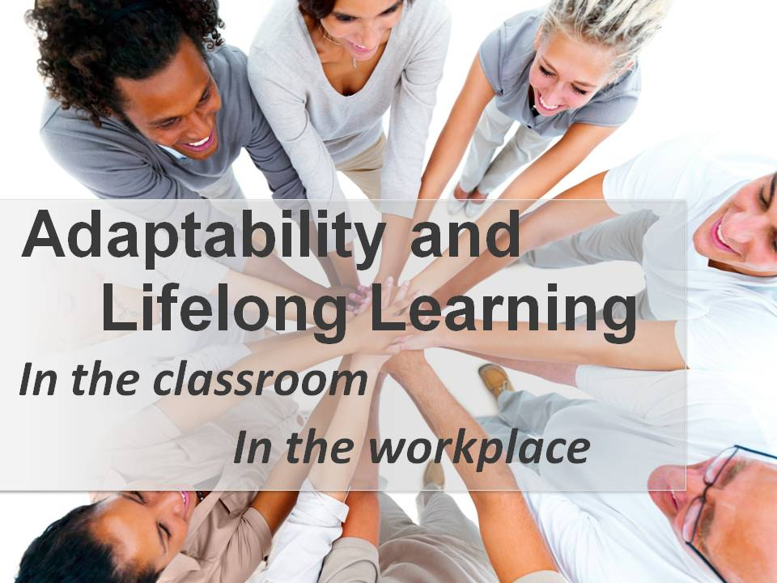
2 | 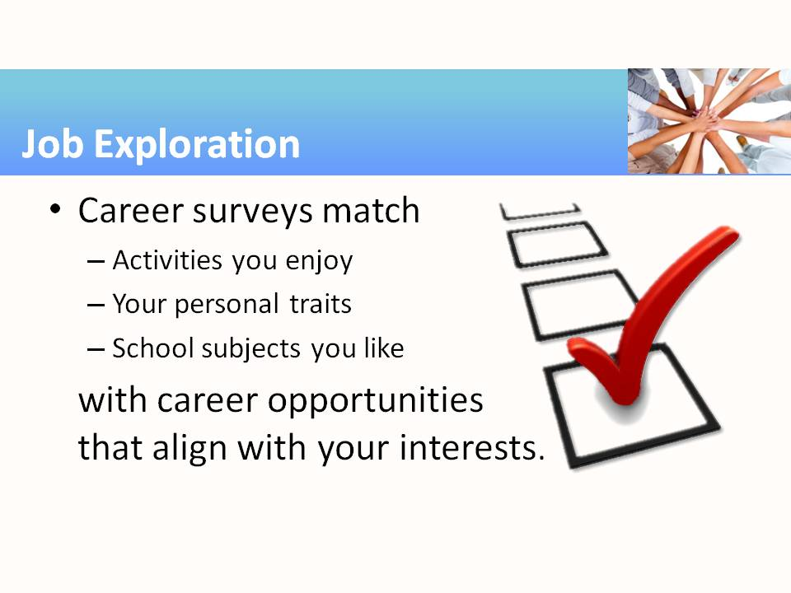 | - The first activity in this module encourages students to complete one or more of the many career surveys available online, which strive to match personality traits and professional skills with the many available career areas.  - The handout available for this activity lists thousands that have profiles available at the U.S. Dept. of Labor website. Spend a few minutes with students perusing that handout or exploring the website.
3 | 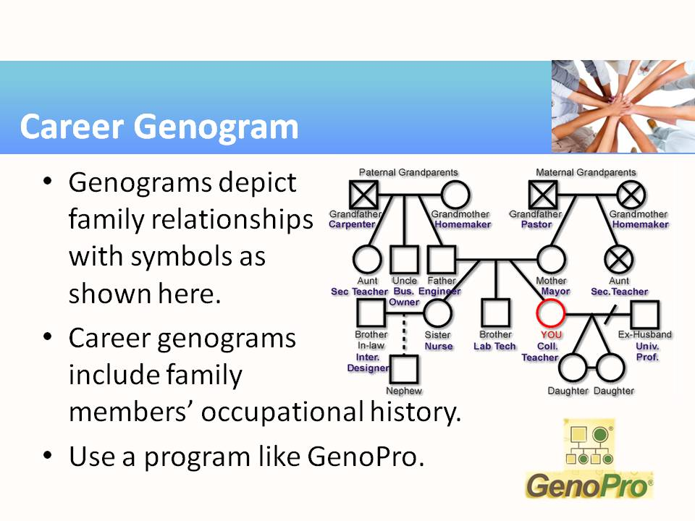 | - Ask students to interpret (guess from the context) the few symbols used in the sketch: squares are males, circles are females, “X” indicates deceased, horizontal lines indicate family members (by marriage or birth), diagonal or vertical lines indicate offspring, joined diagonal lines indicate twins (or triplets), horizontal lines joining twins indicate identical twins, dashed lines indicate adoption, crossed-out lines indicate divorce, and members at the same vertical level are in approximately the same generation. It’s likely that genograms will be encountered with slightly different notations. There is a summary of genogram notations at http://en.wikipedia.org/wiki/Genogram  - Career genograms are interesting because they often suggest possible explanations for why you or your family members may be inclined to follow certain career paths. Might it be because, at your family gatherings, the topics of discussion are about the careers represented around the room?  - We suggest using a free trial version of GenoPro for this activity.
4 | 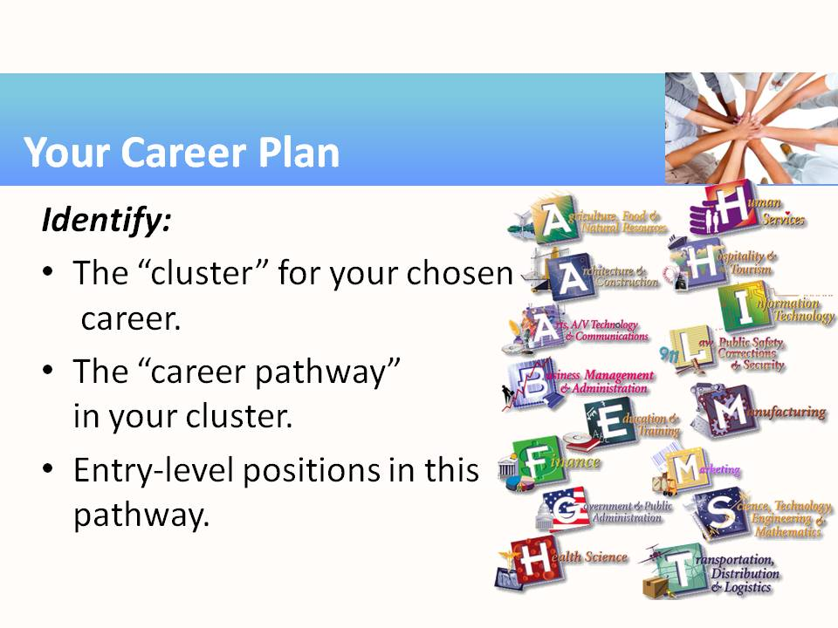 | - Students may not be aware of the many career clusters other than the ones they are pursuing. You can take a moment to rattle off the names of a few others. It’s a good thing that we are all different, so there are folks to fill all those important jobs that don’t interest us!  - So, within the chosen cluster, students should identify a career pathway from the many available ones, and then identify an entry-level position that matches their skills and ambitions. See the next slide for more ideas about this activity.
5 | 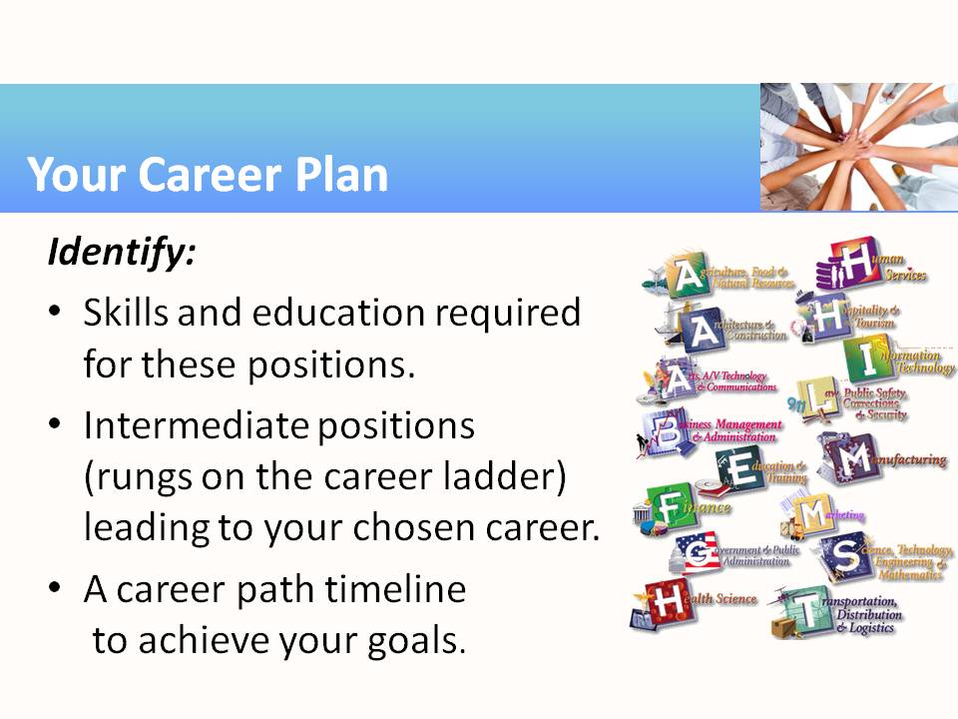 | - Students should select workplace positions that match their skills and serve as a pathway to advancement to their future goals. We hope that the entry-level position is not their final ambition.
6 | 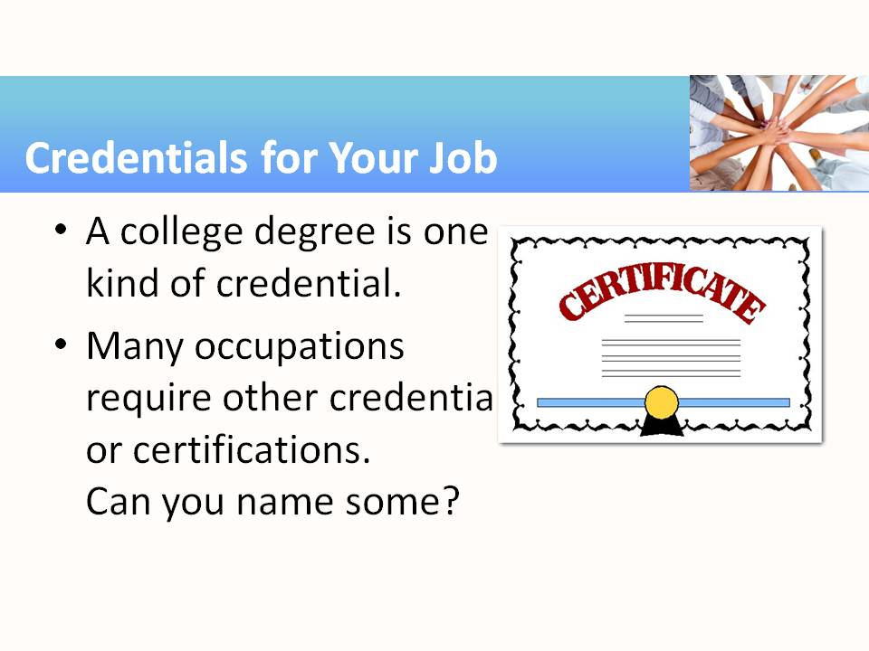 | - Encourage students to name examples of credentials they know about, and then fill in the blanks from the following list, or additional ones from your own career area: accountants, auditors, financial planner, architect, radio operator, broadcast television engineer, structural engineer, insurance counselor, land surveyor, tax preparer, systems engineer, electrical engineer, network administrator, psychologist, veterinary assistant, chiropractor, dental assistant, doctor or nurse or therapist (of any type), medical dispatcher, emergency medical technician, paramedic, massage therapist, social worker, hypnotherapist, acupuncturist, real estate agent, investment manager, notary public, attorney or paralegal or legal secretary (of any type), emergency manager.  - Discussion questions: As a consumer, do you have more confidence in people who hold credentials? Some credentials and licenses require yearly continuing education or re-testing rather than simply a degree. Why do you think this is so?
7 | 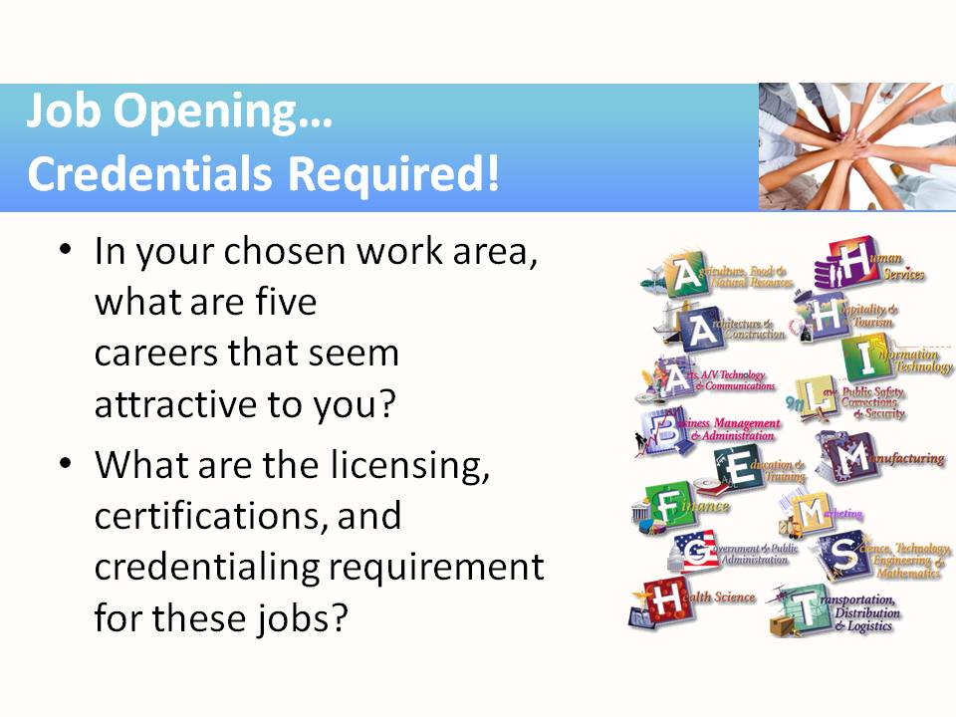 | - These questions can be used as starters for the credentialing activity in this module.
8 | 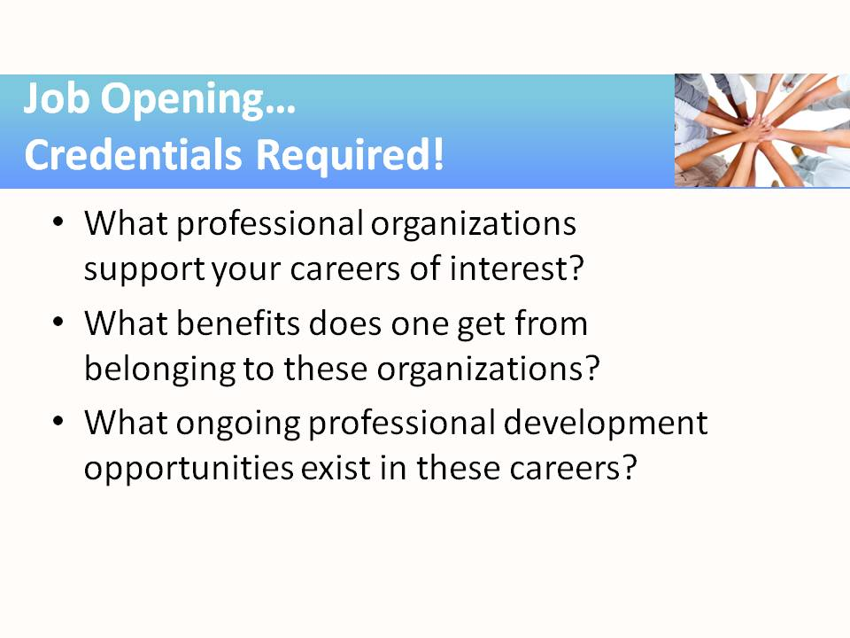 | - These questions can be used as starters for the credentialing activity in this module.
9 | 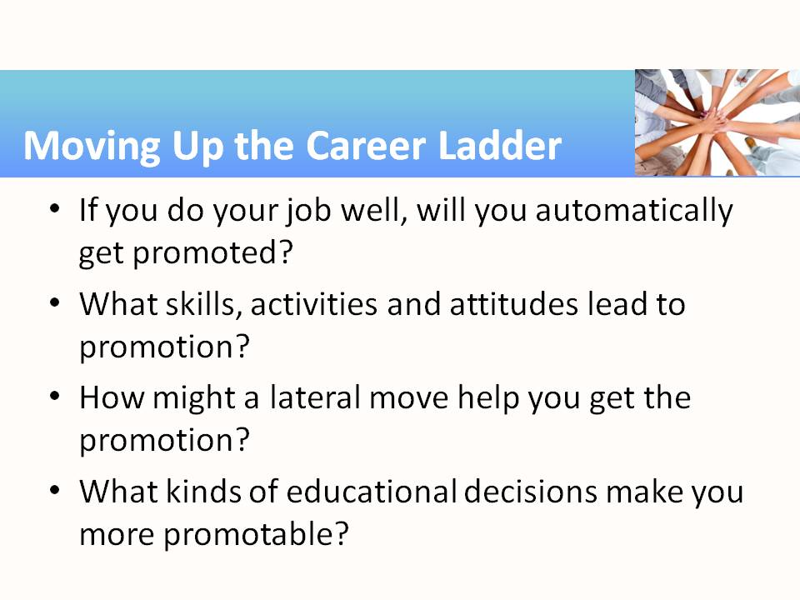 | - Students probably realize that there are no automatic promotions these days. Prompt them to reflect on the questions provided. Acquiring new or advanced skills, participating in professional activities that demonstrate commitment to the career field, participating in hobbies that build skills, and demonstrating mastery of “soft skills” such as communication and dependability are the types of efforts that lead to promotion. A lateral move (e.g., to another department at the same pay grade) provides the opportunity to work in other divisions within the company and practice skills that are immediately relevant to the company.
10 | 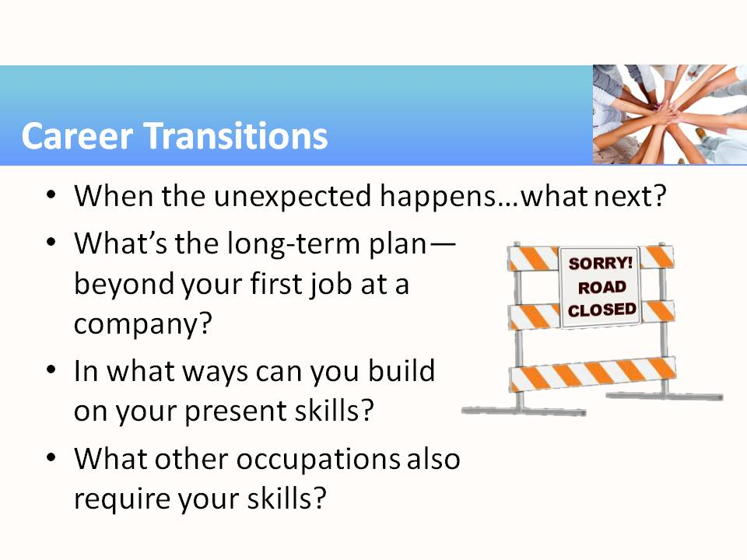 | - In this activity, students should not become unduly alarmed, but they do need to consider the possibility that the unexpected could happen, and their perfect career plan might crumble. It might be unexpected catastrophe, a decision by upper management to downsize, a change in the economic situation, the unexpected arrival of a son or daughter, or maybe even retirement. Any number of things can cause our plans to change.  - Links in the activity should be explored by students.
11 | 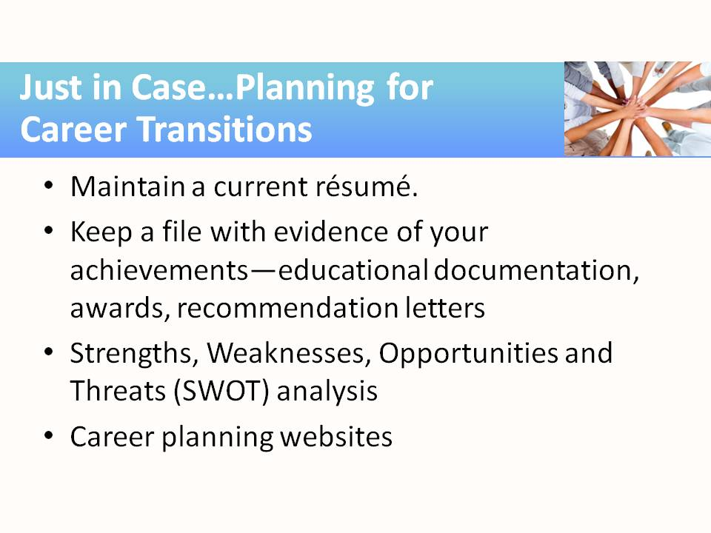 | - Links given in the activity should be explored by students:  - http://www.myskillsmyfuture.org/  - http://www.careerinfonet.org/skills/  - http://www.onetonline.org/search/
12 | 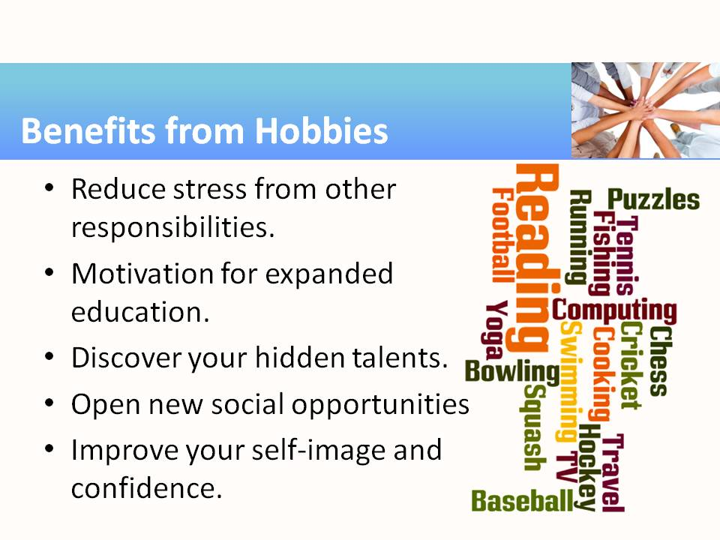 | - Hobbies can improve both personal well-being and academic success and provide a balance to the stress of life’s responsibilities.  - Give opportunity for exploring other areas of interest, possibly leading to expanded education, training, or even a career change.  - Provide incentive and opportunity to apply or even discover one’s creativity and talents, without the pressure of work expectations.  - Open up a new world of social opportunities with others who share an interest in similar hobby area(s). Such interactions often open doors for career moves through networking.  - Boost self-image and self-confidence to help find, practice, improve at, and be recognized for “something you’re good at.”
13 | 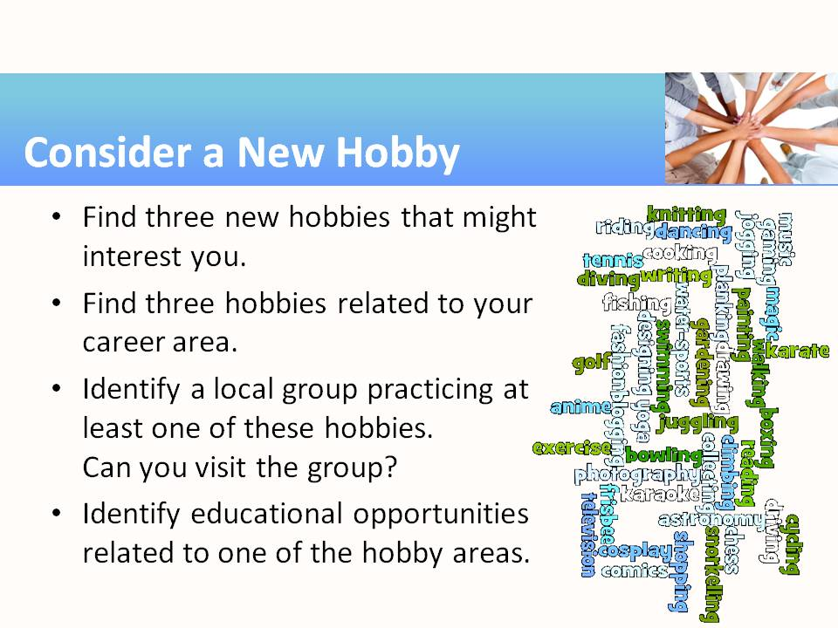 | - This slide summarizes the module’s hobby activity guidelines.
14 | 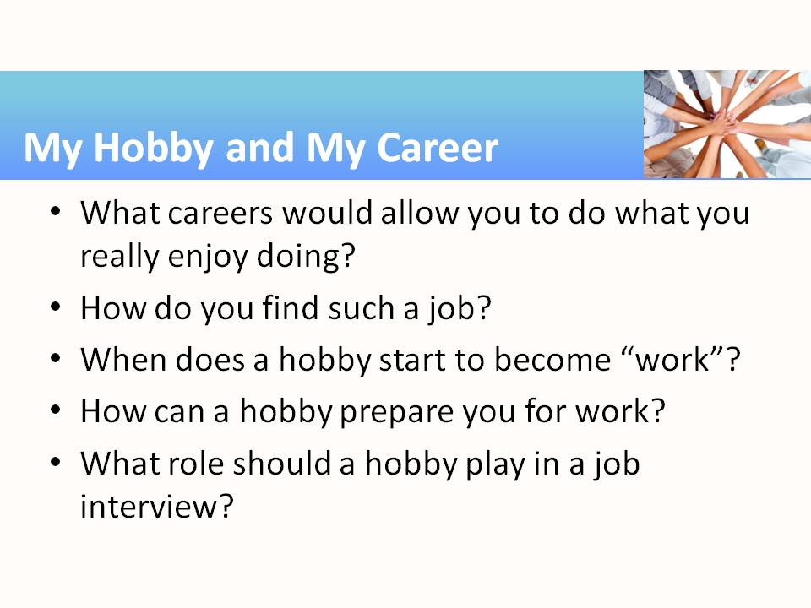 | - Prompt students to reflect on these questions and research the answers, if necessary.
15 | 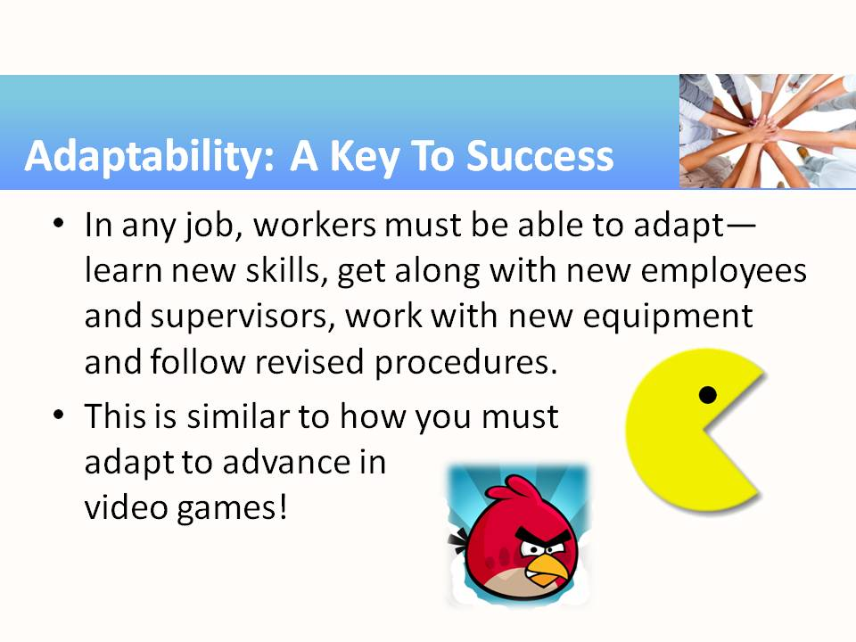 | - Yes, you must adapt to advance in video games. Think about it: You make it past the first few levels just fine, and then what? You must learn something new, or apply a different skill to continue to advance. So, we’re going to recognize that strategy and apply it to lifelong learning.
16 | 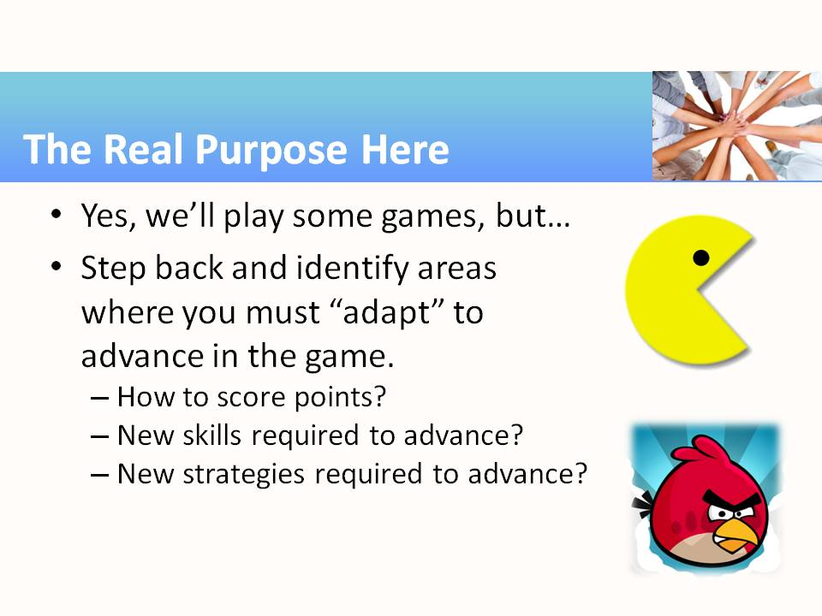 | - So, these are the questions we’d like the students to answer for the games, and then for their job/career.
17 | 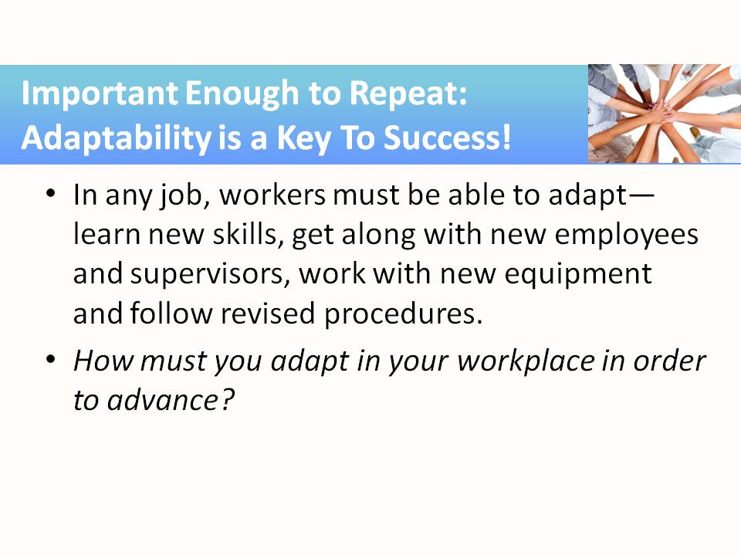
18 | 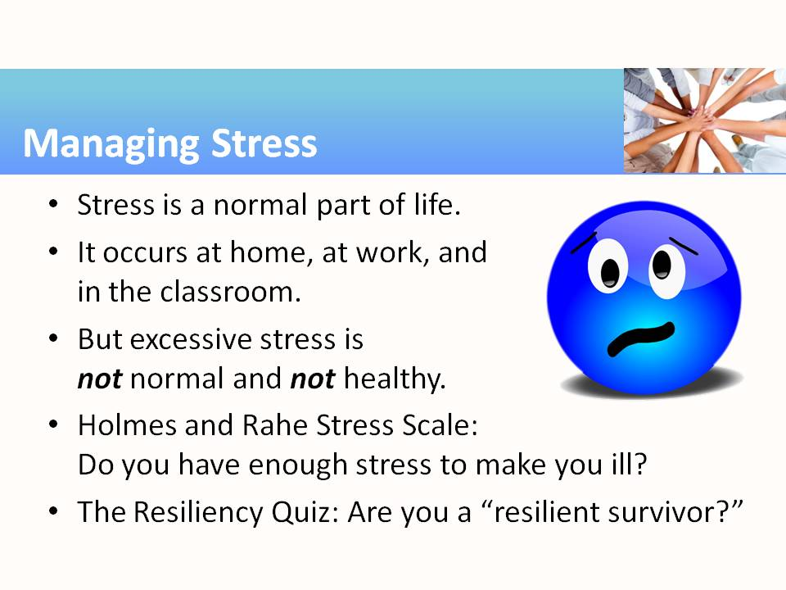 | - This activity directs students to take a couple of quick quizzes online that provide a score as an indicator of their stress level and their ability to cope. Of course, the results are 1) only as reliable as the input, and 2) generalized based on population averages (not able to reflect an individual’s unusual psychological makeup or circumstances). Students should be directed not to take these results too seriously, but maybe to start thinking about their lives. Instructors can use the results as a discussion starter about stress and resiliency.  - Students may approach instructors privately with concerns following the discussion on stress. Please be prepared to give students appropriate referrals to services provided by the campus and the community.
19 | 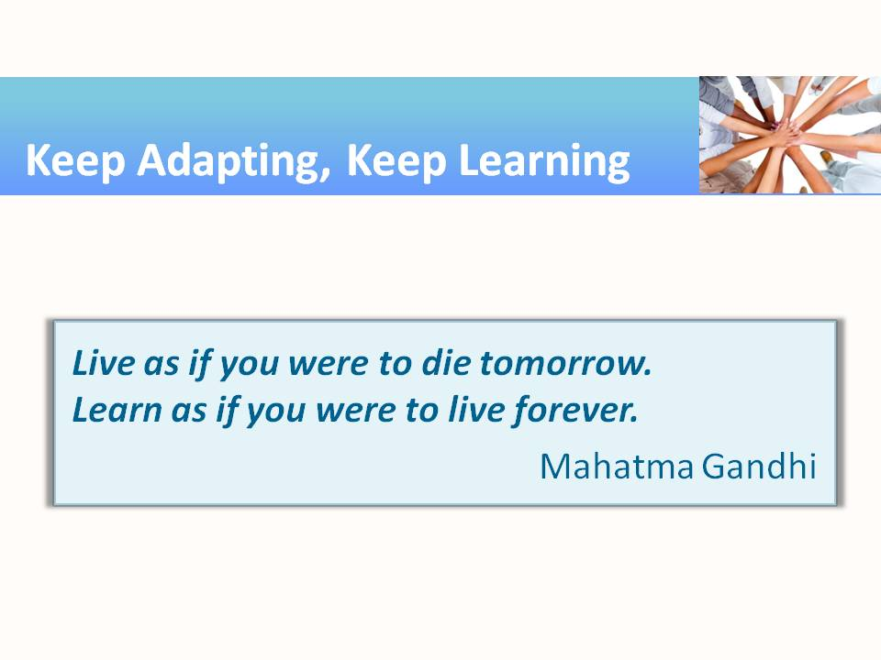 | - http://www.brainyquote.com/quotes/quotes/m/mahatmagan133995.html
Teaching Resources
Activities
The following activities are examples of activities that can be completed in class to emphasize, teach, and practice Adaptability and Lifelong Learning. The activities can be used as included in this resource, or they may be adapted and tailored to fit the specific courses being taught. Suggestions for tailoring the activities precede each activity with examples from several different subject areas/career pathways. The suggested modifications are provided as examples for instructors with ideas of how they might tailor the activity to fit with the content they are already teaching.

Activity: Job Exploration and Genograms
Instructor Preparation
This activity is primarily aimed at students who have not already completed one or more career survey instruments. However, the optional career genogram may interest others.
Everyone has different preferences and different personal goals. Many career surveys exist that can help students describe themselves, identify the subjects they like and dislike, the activities in which they do well and those they do poorly. These surveys attempt to mechanically summarize the responses and reveal which career clusters might be a match for students’ interests and capabilities. Even if they completed a career survey several years ago, it will be helpful for them to complete one again. It will provide insight about areas of strengths and weakness and how those align with today’s career opportunities.
An optional part of this activity asks students to consider the careers in their family. We all inherit more than just genes from our parents and close family members; we are also influenced by observing their conversations, hobbies, extracurricular activities, travels, and other interests and activities. A career genogram tracing one’s family tree (back to grandparents or farther, if desired) examines the careers that each family member pursued. Creating a career genogram can be personally rewarding and help students examine the competencies and strengths obtained from their family, as it might impact their own career search.
Objectives
Students will:
- Complete one or more career-choice survey instrument.
- Complete a career genogram (a family tree of career paths; requires some outside research information by the student about their family history).
Materials
- Internet access to career survey instruments or interest inventories.
- Internet access to career exploration websites.
- Handouts 1 and 2
- Optional: Student’s own family tree information, including occupational history.
Activity Guidelines
In the first part of this activity, students should visit any one of several career planning websites (see the Web Links section of this module) to complete a survey, and then compare the results with fellow students (at instructor’s discretion). It would be interesting for students to complete survey instruments from more than one site and compare those results.
When completing the surveys, it’s important to answer the questions honestly. Trying to answer the questions in a contrived or anticipated way will produce confusing results.
Most of the surveys suggest career paths that align with the results and some of these suggestions surprise students. Direct them to speculate about those surprising careers.
- Why did the survey suggest ____ (an unexpected career)?
- Which of the suggested careers would require additional education, preparation, certifications, etc.?
Handout 1 provides an exhaustive list of careers, taken from the US Department of Labor sponsored web-site (http://www.careerinfonet.org), grouped by career clusters. Focusing on the cluster for the career area chosen can be very enlightening.
Once students have an indication of an interesting career choice, they can explore those careers further at the U. S. Department of Labor supported website, http://www.careerinfonet.org/Explore/. The Career and Cluster Videos link, http://www.careeronestop.org/Videos/default.aspx, provides access to over 500 videos that explore occupations across all 16 career clusters.
Career Genogram
For the second part of this activity, direct students to complete a career genogram—a family tree of their family’s occupational history. A career genogram is designed to help students understand the educational and occupational choices made by past and present family members and to provide insight into their own perspectives on educational and career goals.
Get trial version at GenoPro.com
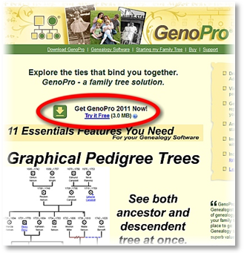
Click “Try It Free” link.
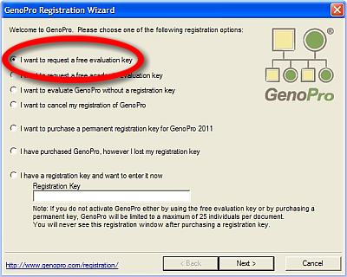
Request a Free Registration Key
Ask students to start with the history of their grandparents. (They can go further back if family information is available.) After completing the genogram (see Handout 2), students should discuss it with at least one other student to gain additional insights. Then, using the suggested analysis questions on Handout 2, students should write a short paper (1-5 pages) summarizing the trends in their family and the influences that family members might have had on one another. The focus of this assignment should be on the student’s family, not themselves.
The pictorial representations known as genograms can be created from scratch using basic shapes available through most word processors organization chart tools, basic drawing programs, or by just drawing and labeling the shapes and lines by hand. The resulting product needs to be neat and easy to read.
There is a free trial genealogy program available from https://www.genopro.com/ that can be used to make genograms quickly. Go to the GenoPro website, click the “Try it Free” button, save the download file, and install it. With the registration wizard, apply and receive a free registration key which is good for a few weeks of trial use—adequate for this activity.
Handout 1—Occupational Profiles from U.S. Department of Labor, by Cluster

Architecture and Engineering
Aerospace Engineering and Operations Technicians
Aerospace Engineers
Agricultural Engineers
Architects, Except Landscape and Naval
Architectural and Civil Drafters
Biomedical Engineers
Cartographers and Photogrammetrists
Chemical Engineers
Civil Engineering Technicians
Civil Engineers
Computer Hardware Engineers
Drafters, All Other
Electrical Engineers
Electrical and Electronics Drafters
Electrical and Electronics Engineering Technicians
Electro-Mechanical Technicians
Electronics Engineers, Except Computer
Engineering Technicians, Except Drafters, All Other
Engineers, All Other
Environmental Engineering Technicians
Environmental Engineers
Health and Safety Engineers, Except Mining Safety Engineers and Inspectors
Industrial Engineering Technicians
Industrial Engineers
Landscape Architects
Marine Engineers and Naval Architects
Materials Engineers
Mechanical Drafters
Mechanical Engineering Technicians
Mechanical Engineers
Mining and Geological Engineers, Including Mining Safety Engineers
Nuclear Engineers
Petroleum Engineers
Surveying and Mapping Technicians
Surveyors
Arts, Design, Entertainment, Sports, and Media
Actors
Art Directors
Artists and Related Workers, All Other
Athletes and Sports Competitors
Audio and Video Equipment Technicians
Broadcast News Analysts
Broadcast Technicians
Camera Operators, Television, Video, and Motion Picture
Choreographers
Coaches and Scouts
Commercial and Industrial Designers
Craft Artists
Dancers
Designers, All Other
Editors
Entertainers and Performers, Sports and Related Workers, All Other
Fashion Designers
Film and Video Editors
Fine Artists, Including Painters, Sculptors, and Illustrators
Floral Designers
Graphic Designers
Interior Designers
Interpreters and Translators
Media and Communication Equipment Workers, All Other
Media and Communication Workers, All Other
Merchandise Displayers and Window Trimmers
Multimedia Artists and Animators
Music Directors and Composers
Musicians and Singers
Photographers
Producers and Directors
Public Address System and Other Announcers
Public Relations Specialists
Radio Operators
Radio and Television Announcers
Reporters and Correspondents
Set and Exhibit Designers
Sound Engineering Technicians
Technical Writers
Umpires, Referees, and Other Sports Officials
Writers and Authors
Building and Grounds Cleaning and Maintenance
Building Cleaning Workers, All Other
First-Line Supervisors of Housekeeping and Janitorial Workers
First-Line Supervisors of Landscaping, Lawn Service, and Groundskeeping Workers
Grounds Maintenance Workers, All Other
Janitors and Cleaners, Except Maids and Housekeeping Cleaners
Landscaping and Groundskeeping Workers
Maids and Housekeeping Cleaners
Pest Control Workers
Pesticide Handlers, Sprayers, and Applicators, Vegetation
Tree Trimmers and Pruners
Business and Financial Operations
Accountants and Auditors
Agents and Business Managers of Artists, Performers, and Athletes
Appraisers and Assessors of Real Estate
Budget Analysts
Business Operations Specialists, All Other
Buyers and Purchasing Agents, Farm Products
Claims Adjusters, Examiners, and Investigators
Compensation, Benefits, and Job Analysis Specialists
Compliance Officers
Cost Estimators
Credit Analysts
Credit Counselors
Farm Labor Contractors
Financial Analysts
Financial Examiners
Financial Specialists, All Other
Fundraisers
Human Resources Specialists
Insurance Appraisers, Auto Damage
Insurance Underwriters
Labor Relations Specialists
Loan Officers
Logisticians
Management Analysts
Market Research Analysts and Marketing Specialists
Meeting, Convention, and Event Planners
Personal Financial Advisors
Purchasing Agents, Except Wholesale, Retail, and Farm Products
Tax Examiners and Collectors, and Revenue Agents
Tax Preparers
Training and Development Specialists
Wholesale and Retail Buyers, Except Farm Products
Community and Social Service
Child, Family, and School Social Workers
Clergy
Community Health Workers
Community and Social Service Specialists, All Other
Counselors, All Other
Directors, Religious Activities and Education
Educational, Guidance, School, and Vocational Counselors
Health Educators
Healthcare Social Workers
Marriage and Family Therapists
Mental Health Counselors
Mental Health and Substance Abuse Social Workers
Probation Officers and Correctional Treatment Specialists
Rehabilitation Counselors
Religious Workers, All Other
Social Workers, All Other
Social and Human Service Assistants
Substance Abuse and Behavioral Disorder Counselors
Computer and Mathematical
Actuaries
Computer Network Architects
Computer Network Support Specialists
Computer Occupations, All Other
Computer Programmers
Computer Systems Analysts
Computer User Support Specialists
Computer and Information Research Scientists
Database Administrators
Information Security Analysts
Mathematical Science Occupations, All Other
Mathematical Technicians
Mathematicians
Network and Computer Systems Administrators
Operations Research Analysts
Software Developers, Applications
Software Developers, Systems Software
Statisticians
Web Developers
Construction and Extraction
Boilermakers
Brickmasons and Blockmasons
Carpenters
Carpet Installers
Cement Masons and Concrete Finishers
Construction Laborers
Construction and Building Inspectors
Construction and Related Workers, All Other
Continuous Mining Machine Operators
Derrick Operators, Oil and Gas
Drywall and Ceiling Tile Installers
Earth Drillers, Except Oil and Gas
Electricians
Elevator Installers and Repairers
Explosives Workers, Ordnance Handling Experts, and Blasters
Extraction Workers, All Other
Fence Erectors
First-Line Supervisors of Construction Trades and Extraction Workers
Floor Layers, Except Carpet, Wood, and Hard Tiles
Floor Sanders and Finishers
Glaziers
Hazardous Materials Removal Workers
Helpers, Construction Trades, All Other
Helpers--Brickmasons, Blockmasons, Stonemasons, and Tile and Marble Setters
Helpers--Carpenters
Helpers--Electricians
Helpers--Extraction Workers
Helpers--Painters, Paperhangers, Plasterers, and Stucco Masons
Helpers--Pipelayers, Plumbers, Pipefitters, and Steamfitters
Helpers--Roofers
Highway Maintenance Workers
Insulation Workers, Floor, Ceiling, and Wall
Insulation Workers, Mechanical
Mine Cutting and Channeling Machine Operators
Mining Machine Operators, All Other
Operating Engineers and Other Construction Equipment Operators
Painters, Construction and Maintenance
Paperhangers
Paving, Surfacing, and Tamping Equipment Operators
Pile-Driver Operators
Pipelayers
Plasterers and Stucco Masons
Plumbers, Pipefitters, and Steamfitters
Rail-Track Laying and Maintenance Equipment Operators
Reinforcing Iron and Rebar Workers
Rock Splitters, Quarry
Roof Bolters, Mining
Roofers
Rotary Drill Operators, Oil and Gas
Roustabouts, Oil and Gas
Segmental Pavers
Septic Tank Servicers and Sewer Pipe Cleaners
Service Unit Operators, Oil, Gas, and Mining
Sheet Metal Workers
Solar Photovoltaic Installers
Stonemasons
Structural Iron and Steel Workers
Tapers
Terrazzo Workers and Finishers
Tile and Marble Setters
Education, Training, and Library
Adult Basic and Secondary Education and Literacy Teachers and Instructors
Agricultural Sciences Teachers, Postsecondary
Anthropology and Archeology Teachers, Postsecondary
Architecture Teachers, Postsecondary
Archivists
Area, Ethnic, and Cultural Studies Teachers, Postsecondary
Art, Drama, and Music Teachers, Postsecondary
Atmospheric, Earth, Marine, and Space Sciences Teachers, Postsecondary
Audio-Visual and Multimedia Collections Specialists
Biological Science Teachers, Postsecondary
Business Teachers, Postsecondary
Career/Technical Education Teachers, Middle School
Career/Technical Education Teachers, Secondary School
Chemistry Teachers, Postsecondary
Communications Teachers, Postsecondary
Computer Science Teachers, Postsecondary
Criminal Justice and Law Enforcement Teachers, Postsecondary
Curators
Economics Teachers, Postsecondary
Education Teachers, Postsecondary
Education, Training, and Library Workers, All Other
Elementary School Teachers, Except Special Education
Engineering Teachers, Postsecondary
English Language and Literature Teachers, Postsecondary
Environmental Science Teachers, Postsecondary
Farm and Home Management Advisors
Foreign Language and Literature Teachers, Postsecondary
Forestry and Conservation Science Teachers, Postsecondary
Geography Teachers, Postsecondary
Graduate Teaching Assistants
Health Specialties Teachers, Postsecondary
History Teachers, Postsecondary
Home Economics Teachers, Postsecondary
Instructional Coordinators
Kindergarten Teachers, Except Special Education
Law Teachers, Postsecondary
Librarians
Library Science Teachers, Postsecondary
Library Technicians
Mathematical Science Teachers, Postsecondary
Middle School Teachers, Except Special and Career/Technical Education
Museum Technicians and Conservators
Nursing Instructors and Teachers, Postsecondary
Philosophy and Religion Teachers, Postsecondary
Physics Teachers, Postsecondary
Political Science Teachers, Postsecondary
Postsecondary Teachers, All Other
Preschool Teachers, Except Special Education
Psychology Teachers, Postsecondary
Recreation and Fitness Studies Teachers, Postsecondary
Secondary School Teachers, Except Special and Career/Technical Education
Self-Enrichment Education Teachers
Social Sciences Teachers, Postsecondary, All Other
Social Work Teachers, Postsecondary
Sociology Teachers, Postsecondary
Special Education Teachers, All Other
Special Education Teachers, Kindergarten and Elementary School
Special Education Teachers, Middle School
Special Education Teachers, Preschool
Special Education Teachers, Secondary School
Teacher Assistants
Teachers and Instructors, All Other
Vocational Education Teachers, Postsecondary
Farming, Fishing, and Forestry
Agricultural Equipment Operators
Agricultural Inspectors
Agricultural Workers, All Other
Animal Breeders
Fallers
Farmworkers and Laborers, Crop, Nursery, and Greenhouse
Farmworkers, Farm, Ranch, and Aquacultural Animals
First-Line Supervisors of Farming, Fishing, and Forestry Workers
Fishers and Related Fishing Workers
Forest and Conservation Workers
Graders and Sorters, Agricultural Products
Hunters and Trappers
Log Graders and Scalers
Logging Equipment Operators
Logging Workers, All Other
Food Preparation and Serving Related
Bartenders
Chefs and Head Cooks
Combined Food Preparation and Serving Workers, Including Fast Food
Cooks, All Other
Cooks, Fast Food
Cooks, Institution and Cafeteria
Cooks, Private Household
Cooks, Restaurant
Cooks, Short Order
Counter Attendants, Cafeteria, Food Concession, and Coffee Shop
Dining Room and Cafeteria Attendants and Bartender Helpers
Dishwashers
First-Line Supervisors of Food Preparation and Serving Workers
Food Preparation Workers
Food Preparation and Serving Related Workers, All Other
Food Servers, Nonrestaurant
Hosts and Hostesses, Restaurant, Lounge, and Coffee Shop
Waiters and Waitresses
Healthcare Practitioners and Technical
Anesthesiologists
Athletic Trainers
Audiologists
Cardiovascular Technologists and Technicians
Chiropractors
Dental Hygienists
Dentists, All Other Specialists
Dentists, General
Diagnostic Medical Sonographers
Dietetic Technicians
Dietitians and Nutritionists
Emergency Medical Technicians and Paramedics
Exercise Physiologists
Family and General Practitioners
Genetic Counselors
Health Diagnosing and Treating Practitioners, All Other
Health Technologists and Technicians, All Other
Healthcare Practitioners and Technical Workers, All Other
Hearing Aid Specialists
Internists, General
Licensed Practical and Licensed Vocational Nurses
Magnetic Resonance Imaging Technologists
Medical Records and Health Information Technicians
Medical and Clinical Laboratory Technicians
Medical and Clinical Laboratory Technologists
Nuclear Medicine Technologists
Nurse Anesthetists
Nurse Midwives
Nurse Practitioners
Obstetricians and Gynecologists
Occupational Health and Safety Specialists
Occupational Health and Safety Technicians
Occupational Therapists
Ophthalmic Medical Technicians
Opticians, Dispensing
Optometrists
Oral and Maxillofacial Surgeons
Orthodontists
Orthotists and Prosthetists
Pediatricians, General
Pharmacists
Pharmacy Technicians
Physical Therapists
Physician Assistants
Physicians and Surgeons, All Other
Podiatrists
Prosthodontists
Psychiatric Technicians
Psychiatrists
Radiation Therapists
Radiologic Technologists
Recreational Therapists
Registered Nurses
Respiratory Therapists
Respiratory Therapy Technicians
Speech-Language Pathologists
Surgeons
Surgical Technologists
Therapists, All Other
Veterinarians
Veterinary Technologists and Technicians
Healthcare Support
Dental Assistants
Healthcare Support Workers, All Other
Home Health Aides
Massage Therapists
Medical Assistants
Medical Equipment Preparers
Medical Transcriptionists
Nursing Assistants
Occupational Therapy Aides
Occupational Therapy Assistants
Orderlies
Pharmacy Aides
Phlebotomists
Physical Therapist Aides
Physical Therapist Assistants
Psychiatric Aides
Veterinary Assistants and Laboratory Animal Caretakers
Installation, Maintenance, and Repair
Aircraft Mechanics and Service Technicians
Automotive Body and Related Repairers
Automotive Glass Installers and Repairers
Automotive Service Technicians and Mechanics
Avionics Technicians
Bicycle Repairers
Bus and Truck Mechanics and Diesel Engine Specialists
Camera and Photographic Equipment Repairers
Coin, Vending, and Amusement Machine Servicers and Repairers
Commercial Divers
Computer, Automated Teller, and Office Machine Repairers
Control and Valve Installers and Repairers, Except Mechanical Door
Electric Motor, Power Tool, and Related Repairers
Electrical Power-Line Installers and Repairers
Electrical and Electronics Installers and Repairers, Transportation Equipment
Electrical and Electronics Repairers, Commercial and Industrial Equipment
Electrical and Electronics Repairers, Powerhouse, Substation, and Relay
Electronic Equipment Installers and Repairers, Motor Vehicles
Electronic Home Entertainment Equipment Installers and Repairers
Fabric Menders, Except Garment
Farm Equipment Mechanics and Service Technicians
First-Line Supervisors of Mechanics, Installers, and Repairers
Heating, Air Conditioning, and Refrigeration Mechanics and Installers
Helpers--Installation, Maintenance, and Repair Workers
Home Appliance Repairers
Industrial Machinery Mechanics
Installation, Maintenance, and Repair Workers, All Other
Locksmiths and Safe Repairers
Maintenance Workers, Machinery
Maintenance and Repair Workers, General
Manufactured Building and Mobile Home Installers
Mechanical Door Repairers
Medical Equipment Repairers
Millwrights
Mobile Heavy Equipment Mechanics, Except Engines
Motorboat Mechanics and Service Technicians
Motorcycle Mechanics
Musical Instrument Repairers and Tuners
Outdoor Power Equipment and Other Small Engine Mechanics
Precision Instrument and Equipment Repairers, All Other
Radio, Cellular, and Tower Equipment Installers and Repairers
Rail Car Repairers
Recreational Vehicle Service Technicians
Refractory Materials Repairers, Except Brickmasons
Riggers
Security and Fire Alarm Systems Installers
Signal and Track Switch Repairers
Telecommunications Equipment Installers and Repairers, Except Line Installers
Telecommunications Line Installers and Repairers
Tire Repairers and Changers
Watch Repairers
Wind Turbine Service Technicians
Legal
Administrative Law Judges, Adjudicators, and Hearing Officers
Arbitrators, Mediators, and Conciliators
Court Reporters
Judges, Magistrate Judges, and Magistrates
Judicial Law Clerks
Lawyers
Legal Support Workers, All Other
Paralegals and Legal Assistants
Title Examiners, Abstractors, and Searchers
Life, Physical, and Social Science
Agricultural and Food Science Technicians
Animal Scientists
Anthropologists and Archeologists
Astronomers
Atmospheric and Space Scientists
Biochemists and Biophysicists
Biological Scientists, All Other
Biological Technicians
Chemical Technicians
Chemists
Clinical, Counseling, and School Psychologists
Conservation Scientists
Economists
Environmental Science and Protection Technicians, Including Health
Environmental Scientists and Specialists, Including Health
Epidemiologists
Food Scientists and Technologists
Forensic Science Technicians
Forest and Conservation Technicians
Foresters
Geographers
Geological and Petroleum Technicians
Geoscientists, Except Hydrologists and Geographers
Historians
Hydrologists
Industrial-Organizational Psychologists
Life Scientists, All Other
Life, Physical, and Social Science Technicians, All Other
Materials Scientists
Medical Scientists, Except Epidemiologists
Microbiologists
Nuclear Technicians
Physical Scientists, All Other
Physicists
Political Scientists
Psychologists, All Other
Social Science Research Assistants
Social Scientists and Related Workers, All Other
Sociologists
Soil and Plant Scientists
Survey Researchers
Urban and Regional Planners
Zoologists and Wildlife Biologists
Management
Administrative Services Managers
Advertising and Promotions Managers
Architectural and Engineering Managers
Chief Executives
Compensation and Benefits Managers
Computer and Information Systems Managers
Construction Managers
Education Administrators, All Other
Education Administrators, Elementary and Secondary School
Education Administrators, Postsecondary
Education Administrators, Preschool and Childcare Center/Program
Emergency Management Directors
Farmers, Ranchers, and Other Agricultural Managers
Financial Managers
Food Service Managers
Funeral Service Managers
Gaming Managers
General and Operations Managers
Human Resources Managers
Industrial Production Managers
Legislators
Lodging Managers
Managers, All Other
Marketing Managers
Medical and Health Services Managers
Natural Sciences Managers
Postmasters and Mail Superintendents
Property, Real Estate, and Community Association Managers
Public Relations and Fundraising Managers
Purchasing Managers
Sales Managers
Social and Community Service Managers
Training and Development Managers
Transportation, Storage, and Distribution Managers
Office and Administrative Support
Bill and Account Collectors
Billing and Posting Clerks
Bookkeeping, Accounting, and Auditing Clerks
Brokerage Clerks
Cargo and Freight Agents
Communications Equipment Operators, All Other
Computer Operators
Correspondence Clerks
Couriers and Messengers
Court, Municipal, and License Clerks
Credit Authorizers, Checkers, and Clerks
Customer Service Representatives
Data Entry Keyers
Desktop Publishers
Dispatchers, Except Police, Fire, and Ambulance
Eligibility Interviewers, Government Programs
Executive Secretaries and Executive Administrative Assistants
File Clerks
Financial Clerks, All Other
First-Line Supervisors of Office and Administrative Support Workers
Gaming Cage Workers
Hotel, Motel, and Resort Desk Clerks
Human Resources Assistants, Except Payroll and Timekeeping
Information and Record Clerks, All Other
Insurance Claims and Policy Processing Clerks
Interviewers, Except Eligibility and Loan
Legal Secretaries
Library Assistants, Clerical
Loan Interviewers and Clerks
Mail Clerks and Mail Machine Operators, Except Postal Service
Medical Secretaries
Meter Readers, Utilities
New Accounts Clerks
Office Clerks, General
Office Machine Operators, Except Computer
Office and Administrative Support Workers, All Other
Order Clerks
Payroll and Timekeeping Clerks
Police, Fire, and Ambulance Dispatchers
Postal Service Clerks
Postal Service Mail Carriers
Postal Service Mail Sorters, Processors, and Processing Machine Operators
Procurement Clerks
Production, Planning, and Expediting Clerks
Proofreaders and Copy Markers
Receptionists and Information Clerks
Reservation and Transportation Ticket Agents and Travel Clerks
Secretaries and Administrative Assistants, Except Legal, Medical, and Executive
Shipping, Receiving, and Traffic Clerks
Statistical Assistants
Stock Clerks and Order Fillers
Switchboard Operators, Including Answering Service
Telephone Operators
Tellers
Weighers, Measurers, Checkers, and Samplers, Recordkeeping
Word Processors and Typists
Personal Care and Service
Amusement and Recreation Attendants
Animal Trainers
Baggage Porters and Bellhops
Barbers
Childcare Workers
Concierges
Costume Attendants
Embalmers
Entertainment Attendants and Related Workers, All Other
First-Line Supervisors of Personal Service Workers
Fitness Trainers and Aerobics Instructors
Funeral Attendants
Gaming Dealers
Gaming Service Workers, All Other
Gaming Supervisors
Gaming and Sports Book Writers and Runners
Hairdressers, Hairstylists, and Cosmetologists
Locker Room, Coatroom, and Dressing Room Attendants
Makeup Artists, Theatrical and Performance
Manicurists and Pedicurists
Morticians, Undertakers, and Funeral Directors
Motion Picture Projectionists
Nonfarm Animal Caretakers
Personal Care Aides
Personal Care and Service Workers, All Other
Recreation Workers
Residential Advisors
Shampooers
Skincare Specialists
Slot Supervisors
Tour Guides and Escorts
Travel Guides
Ushers, Lobby Attendants, and Ticket Takers
Production
Adhesive Bonding Machine Operators and Tenders
Aircraft Structure, Surfaces, Rigging, and Systems Assemblers
Assemblers and Fabricators, All Other
Bakers
Butchers and Meat Cutters
Cabinetmakers and Bench Carpenters
Chemical Equipment Operators and Tenders
Chemical Plant and System Operators
Cleaning, Washing, and Metal Pickling Equipment Operators and Tenders
Coating, Painting, and Spraying Machine Setters, Operators, and Tenders
Coil Winders, Tapers, and Finishers
Computer Numerically Controlled Machine Tool Programmers, Metal and Plastic
Computer-Controlled Machine Tool Operators, Metal and Plastic
Cooling and Freezing Equipment Operators and Tenders
Crushing, Grinding, and Polishing Machine Setters, Operators, and Tenders
Cutters and Trimmers, Hand
Cutting and Slicing Machine Setters, Operators, and Tenders
Cutting, Punching, and Press Machine Setters, Operators, and Tenders, Metal and Plastic
Dental Laboratory Technicians
Drilling and Boring Machine Tool Setters, Operators, and Tenders, Metal and Plastic
Electrical and Electronic Equipment Assemblers
Electromechanical Equipment Assemblers
Engine and Other Machine Assemblers
Etchers and Engravers
Extruding and Drawing Machine Setters, Operators, and Tenders, Metal and Plastic
Extruding and Forming Machine Setters, Operators, and Tenders, Synthetic and Glass Fibers
Extruding, Forming, Pressing, and Compacting Machine Setters, Operators, and Tenders
Fabric and Apparel Patternmakers
Fiberglass Laminators and Fabricators
First-Line Supervisors of Production and Operating Workers
Food Batchmakers
Food Cooking Machine Operators and Tenders
Food Processing Workers, All Other
Food and Tobacco Roasting, Baking, and Drying Machine Operators and Tenders
Forging Machine Setters, Operators, and Tenders, Metal and Plastic
Foundry Mold and Coremakers
Furnace, Kiln, Oven, Drier, and Kettle Operators and Tenders
Furniture Finishers
Gas Plant Operators
Grinding and Polishing Workers, Hand
Grinding, Lapping, Polishing, and Buffing Machine Tool Setters, Operators, and Tenders, Metal and Plastic
Heat Treating Equipment Setters, Operators, and Tenders, Metal and Plastic
Helpers--Production Workers
Inspectors, Testers, Sorters, Samplers, and Weighers
Jewelers and Precious Stone and Metal Workers
Lathe and Turning Machine Tool Setters, Operators, and Tenders, Metal and Plastic
Laundry and Dry-Cleaning Workers
Layout Workers, Metal and Plastic
Machinists
Meat, Poultry, and Fish Cutters and Trimmers
Medical Appliance Technicians
Metal Workers and Plastic Workers, All Other
Metal-Refining Furnace Operators and Tenders
Milling and Planing Machine Setters, Operators, and Tenders, Metal and Plastic
Mixing and Blending Machine Setters, Operators, and Tenders
Model Makers, Metal and Plastic
Model Makers, Wood
Molders, Shapers, and Casters, Except Metal and Plastic
Molding, Coremaking, and Casting Machine Setters, Operators, and Tenders, Metal and Plastic
Multiple Machine Tool Setters, Operators, and Tenders, Metal and Plastic
Nuclear Power Reactor Operators
Ophthalmic Laboratory Technicians
Packaging and Filling Machine Operators and Tenders
Painters, Transportation Equipment
Painting, Coating, and Decorating Workers
Paper Goods Machine Setters, Operators, and Tenders
Patternmakers, Metal and Plastic
Patternmakers, Wood
Petroleum Pump System Operators, Refinery Operators, and Gaugers
Photographic Process Workers and Processing Machine Operators
Plant and System Operators, All Other
Plating and Coating Machine Setters, Operators, and Tenders, Metal and Plastic
Pourers and Casters, Metal
Power Distributors and Dispatchers
Power Plant Operators
Prepress Technicians and Workers
Pressers, Textile, Garment, and Related Materials
Print Binding and Finishing Workers
Printing Press Operators
Production Workers, All Other
Rolling Machine Setters, Operators, and Tenders, Metal and Plastic
Sawing Machine Setters, Operators, and Tenders, Wood
Semiconductor Processors
Separating, Filtering, Clarifying, Precipitating, and Still Machine Setters, Operators, and Tenders
Sewers, Hand
Sewing Machine Operators
Shoe Machine Operators and Tenders
Shoe and Leather Workers and Repairers
Slaughterers and Meat Packers
Stationary Engineers and Boiler Operators
Structural Metal Fabricators and Fitters
Tailors, Dressmakers, and Custom Sewers
Team Assemblers
Textile Bleaching and Dyeing Machine Operators and Tenders
Textile Cutting Machine Setters, Operators, and Tenders
Textile Knitting and Weaving Machine Setters, Operators, and Tenders
Textile Winding, Twisting, and Drawing Out Machine Setters, Operators, and Tenders
Textile, Apparel, and Furnishings Workers, All Other
Timing Device Assemblers and Adjusters
Tire Builders
Tool Grinders, Filers, and Sharpeners
Tool and Die Makers
Upholsterers
Water and Wastewater Treatment Plant and System Operators
Welders, Cutters, Solderers, and Brazers
Welding, Soldering, and Brazing Machine Setters, Operators, and Tenders
Woodworkers, All Other
Woodworking Machine Setters, Operators, and Tenders, Except Sawing
Protective Service
Animal Control Workers
Bailiffs
Correctional Officers and Jailers
Crossing Guards
Detectives and Criminal Investigators
Fire Inspectors and Investigators
Firefighters
First-Line Supervisors of Correctional Officers
First-Line Supervisors of Fire Fighting and Prevention Workers
First-Line Supervisors of Police and Detectives
First-Line Supervisors of Protective Service Workers, All Other
Fish and Game Wardens
Forest Fire Inspectors and Prevention Specialists
Gaming Surveillance Officers and Gaming Investigators
Lifeguards, Ski Patrol, and Other Recreational Protective Service Workers
Parking Enforcement Workers
Police and Sheriff's Patrol Officers
Private Detectives and Investigators
Protective Service Workers, All Other
Security Guards
Transit and Railroad Police
Transportation Security Screeners
Sales and Related
Advertising Sales Agents
Cashiers
Counter and Rental Clerks
Demonstrators and Product Promoters
Door-to-Door Sales Workers, News and Street Vendors, and Related Workers
First-Line Supervisors of Non-Retail Sales Workers
First-Line Supervisors of Retail Sales Workers
Gaming Change Persons and Booth Cashiers
Insurance Sales Agents
Models
Parts Salespersons
Real Estate Brokers
Real Estate Sales Agents
Retail Salespersons
Sales Engineers
Sales Representatives, Services, All Other
Sales Representatives, Wholesale and Manufacturing, Except Technical and Scientific Products
Sales Representatives, Wholesale and Manufacturing, Technical and Scientific Products
Sales and Related Workers, All Other
Securities, Commodities, and Financial Services Sales Agents
Telemarketers
Travel Agents
Transportation and Material Moving
Air Traffic Controllers
Aircraft Cargo Handling Supervisors
Airfield Operations Specialists
Airline Pilots, Copilots, and Flight Engineers
Ambulance Drivers and Attendants, Except Emergency Medical Technicians
Automotive and Watercraft Service Attendants
Bridge and Lock Tenders
Bus Drivers, School or Special Client
Bus Drivers, Transit and Intercity
Captains, Mates, and Pilots of Water Vessels
Cleaners of Vehicles and Equipment
Commercial Pilots
Conveyor Operators and Tenders
Crane and Tower Operators
Dredge Operators
Driver/Sales Workers
Excavating and Loading Machine and Dragline Operators
First-Line Supervisors of Helpers, Laborers, and Material Movers, Hand
First-Line Supervisors of Transportation and Material-Moving Machine and Vehicle Operators
Flight Attendants
Gas Compressor and Gas Pumping Station Operators
Heavy and Tractor-Trailer Truck Drivers
Hoist and Winch Operators
Industrial Truck and Tractor Operators
Laborers and Freight, Stock, and Material Movers, Hand
Light Truck or Delivery Services Drivers
Loading Machine Operators, Underground Mining
Locomotive Engineers
Locomotive Firers
Machine Feeders and Offbearers
Material Moving Workers, All Other
Mine Shuttle Car Operators
Motor Vehicle Operators, All Other
Motorboat Operators
Packers and Packagers, Hand
Parking Lot Attendants
Pump Operators, Except Wellhead Pumpers
Rail Transportation Workers, All Other
Rail Yard Engineers, Dinkey Operators, and Hostlers
Railroad Brake, Signal, and Switch Operators
Railroad Conductors and Yardmasters
Refuse and Recyclable Material Collectors
Sailors and Marine Oilers
Ship Engineers
Subway and Streetcar Operators
Tank Car, Truck, and Ship Loaders
Taxi Drivers and Chauffeurs
Traffic Technicians
Transportation Attendants, Except Flight Attendants
Transportation Inspectors
Transportation Workers, All Other
Wellhead Pumpers

Handout 2—Genogram Analysis
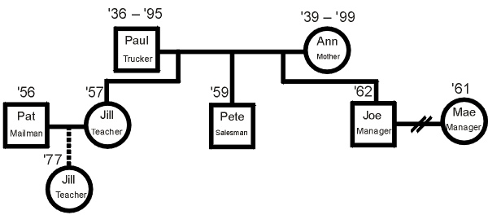
Some basics of genograms:
- Circles represent women, squares represent men.
- Link marriages with horizontal lines; offspring with vertical lines; twins with diagonal lines.
- Solid lines denote direct family relationships; dashed lines indicate adoptions.
- Slashes through a line indicate a divorce.
- Subsequent marriage/partnerships are indicated by a line connected to the other side of a person.
- Deaths are shown by an “X” in the circle or square, with the death year written beside the birth year. Showing a pair of years implies the person is deceased.
- Relevant information is written in or near each individual’s shape, such as:
  - Name
  - Birth year (and death year, if applicable)
  - Highest education level
  - Occupations, skills, talents
  - Optional: Vocational attitudes and values
Using the completed genogram, a student should reflect on each family member’s attitudes by completing sentences like the following (or others provided by the instructor) for each person:
- The kind of work I like to do is…
- Money is …
- To be successful means …
- To be a good person means …
- My advice to you about work is …
Finally, ask them the following questions about their genograms:
- What was easy or difficult about this task?
- How would you describe your family’s educational experience?
- How would you describe your family’s work experience?
- What patterns of occupations/skills/attitudes do you see?
- What behaviors and attitudes were reinforced for males? Females?
- How do your education/career aspirations fit in with your family history in these areas?
- What was your family’s message regarding your career choice?
- Do any family members have unfulfilled goals, aspirations, or fantasies?
- What, if any, should’s or ought to’s did you find?
- Do you see anything that helps you better understand yourself or a family member?
- What surprises did you discover?
- Is there a family member or close friend/mentor you most want to emulate? What draws you to that person/career?
- If you become what these people want you to become, will you be happy?
- What values/interests/attitudes do you seem to have “inherited” from your family?
Group Reflection Questions
This activity is designed to increase a student’s career awareness. During this activity, many students will encounter new job titles and careers that they have never before considered. Encourage students to do a quick internet search of those job titles and identify the typical aptitudes of the job, educational requirements, geographic limitations, financial pros and cons, and so forth, for one or two new occupations.
- What five new job titles in your preferred career area did you discover that you weren’t familiar with before doing this activity?
- Which ones offer the most exciting opportunities?
- Which job title did you need to research to understand what it was?
If this is a student’s first career genogram, they are likely to see patterns not considered before. They should learn that many attitudes, aptitudes, and even abilities can be transmitted from relatives, especially their parents.
- With how many (if any) of your past and present relatives do you share a common interest in a hobby or career?
- What is a common thread that seems to weave through past generations and have an impact on the types of careers chosen?
- How possible is it to break out of the pattern of your past family members’ typical career choices? What would you have to do differently?
Encourage students to share with each other the career areas that seem to weave through their relatives and families. Be sure that students understand that career surveys and genograms should not be perceived as limiting career choices. Instead, genograms can help reveal the job characteristics they might look for in a satisfying career.

Activity: Obtaining and Maintaining Credentials
Instructor Preparation
An increasing number of jobs today require college degrees. A degree, however, isn’t the only kind of credential required. Begin this activity by asking students to think about credentials that people they know might have. Examples might be: My doctor and dentist have diplomas on their office walls that show they graduated from medical or dental school and show any specialty areas and honors that they achieved. The person who cuts my hair has a framed license at his work station that shows he is licensed by the state. My uncle has a commercial license to drive semis to transport goods across the country. My friend’s mom is a journeyman electrician. My brother has top level security clearance.
In this activity, students will learn about different types of credentials that may be available in their chosen career pathway and the requirements for obtaining and maintaining those professional credentials. Examinations and/or demonstration of skill competency may be required. To get a sense of the range of credentialing available, have students visit the following sites or sites that are immediately relevant to their career interests. Keep in mind that while many professional and industrial organizations offer industry certifications, actual licensure may be determined on a state-by-state basis.
- National Council of State Boards of Nursing https://www.ncsbn.org/nclex.htm
- Cisco (IT) certifications http://www.cisco.com/web/learning/certifications/index.html
- North Carolina Department of Agriculture and Consumer Services (agriculture license and permit information) http://www.ncagr.gov/htm/license.htm
- North Carolina Department of Public Instruction (teaching licenses) http://www.dpi.state.nc.us/licensure/
In career and technical education classes, students will probably have already chosen a career cluster, but students in academic classes may still be undecided. Allow students to choose career clusters and career pathways within the clusters that interest them for this activity.
Objectives
Students will:
- Choose a career cluster and identify three to five possible careers in that cluster.
- Examine and list the licensing, certification, and credentialing requirements at the national, state, and local levels for obtaining and maintaining compliance with industry requirements.
- Describe the benefits to an employee of membership in a professional organization.
- To plan for continuing education and training, examine requirements for career advancement.
- Research professional development opportunities needed to stay current on relevant trends and information within the cluster.
Materials
- Computers with internet access
- Handout—Sixteen Career Clusters and Their Pathways
- North Carolina Careers: Career Clusters Guide available at http://www.nccommunitycolleges.edu/sites/default/files/pa-news-files/2015_nc_career_clusters_guide_web_0.pdf (The document is rather long so you may want to print only a few copies of each of the pathways rather than the entire guide. Another option is to allow students to view the cluster that interests them online.)
Activity Guidelines
Begin this activity by asking students what credentials are and what it means to have credentials. Discuss different types of credentials and the fact that some are required and others are voluntary.
- Have students select a career cluster and pathway(s) from the handout, Sixteen Career Clusters and Their Pathways.
- Refer them to the North Carolina Careers: Career Clusters Guide or to the handout, Occupational Profiles from U. S. Department of Labor by Cluster, from the previous activity in this module, and ask them to identify 3-5 specific careers in the career pathway(s) selected.
- For each of the careers, have students identify:
- the entry-level requirements for the job;
- credentials required at the national, state, and local levels to maintain compliance with industry requirements;
- additional voluntary certifications or specializations;
- occupational regulatory agencies or organizations; and
- requirements for maintaining the credentials (e.g. requirements for continuing education, acceptability of online coursework).
- For each of the careers students identified above, ask them to research and list professional organizations available for employees in that field. They should visit the website for at least one of the organizations to find the benefits of belonging to that organization.
- Does the organization provide credentials of any type?
- Does it publish a journal?
- Does it offer online classes or workshops to provide training on specific topics related to the career?
- Does it have local, state, regional, or national meetings or conferences?
- How much does it cost to become a member of the organization?
- What are the requirements for membership?
Group Reflection Questions
Discuss the following questions with your students:
- Do you have a credential of any kind that is necessary for a current job or that was necessary for a previous job? What is it? What were the requirements to obtain it? How often do you need to be recertified? How is that done?
- As a consumer, do credentials give you more confidence in the people who hold them?
- Many credentials and licenses require continuing education and/or retesting to maintain the credential as opposed to simply having a diploma which shows completion of a given course of study. Why do you think this is so?
- If working in a field that offers voluntary credentials, would you seek to obtain the credential? Why?
Handout—Sixteen Career Clusters and Their Pathways
A Career Cluster is a grouping of occupations and broad industries based on commonalities. The sixteen Career Clusters provide an organizing tool for schools, small learning communities, academies, and magnet schools

Agriculture, Food &
Natural Resources
Food Products and Processing Systems
Plant Systems
Animal Systems
Power, Structural & Technical Systems
Natural Resources Systems
Environmental Service Systems
Agribusiness Systems
Architecture and Construction
Design/Pre-Construction
Construction
Maintenance/Operations
Arts, Audio/Video Technology
and Communications
Audio and Video Technology and Film
Printing Technology
Visual Arts
Performing Arts
Journalism and Broadcasting
Telecommunications
Business Management
and Administration
General Management
Business Information Management
Human Resources Management
Operations Management
Administrative Support
Education and Training
Administration and Administrative Support
Professional Support Services
Teaching/Training
Finance
Securities and Investments
Business Finance
Accounting
Insurance
Banking Services

Government and Public
Administration
Governance
National Security
Foreign Service
Planning
Revenue and Taxation
Regulation
Public Management and Administration
Health Science
Therapeutic Services
Diagnostic Services
Health Informatics
Support Services
Biotechnology Research and Development
Hospitality and Tourism
Restaurants and Food/Beverage Services
Lodging
Travel and Tourism
Recreation, Amusements and Attractions
Human Services
Early Childhood Development
and Services
Counseling and Mental Health Services
Family and Community Services
Personal Care Services
Consumer Services
Information Technology
Network Systems
Information Support and Services
Web and Digital Communications
Programming and Software Development
Law, Public Safety, Corrections
and Security
Correction Services
Emergency and Fire Management Services
Security and Protective Services
Law Enforcement Services
Legal Services
Manufacturing
Production
Manufacturing Production Process Development
Maintenance, Installation and Repair
Quality Assurance
Logistics and Inventory Control
Health, Safety and
Environmental Assurance
Marketing
Marketing Management
Professional Sales
Merchandising
Marketing Communications
Marketing Research
Science, Technology,
Engineering and Mathematics
Engineering and Technology
Science and Math
Transportation, Distribution
and Logistics
Transportation Operations
Logistics Planning and Management Services
Warehousing and Distribution Center Operations
Facility and Mobile Equipment Maintenance
Transportation Systems/Infrastructure Planning, Management and Regulation
Health, Safety and Environmental Management
Sales and Service

Activity: Preparing for Career Transitions
Instructor Preparation
Many times people prepare for a first job by going to school or obtaining credentials, but don’t plan beyond that first job. They may have no plan for moving ahead in a career or what to do if that job ceases to be available or they are unable to work at that job. Many may think that having a job automatically leads to having more responsibility and increased wages over time. This lesson discusses the need to prepare for career transitions.
For most people an entry-level job is not the ultimate goal. In the first part of this activity students will plot a possible career path from where they are currently, whether already in the workforce or not yet working, to a first job in the chosen career cluster. They will learn to plan for advancement and will recognize characteristics noticed by managers when considering promotion of current employees. Finally, students will learn that although life sometimes throws a roadblock in the way to the chosen career, they can still find a satisfying career using skills and knowledge they already possess.
The last section of this lesson may be the most important. When an individual has worked hard preparing for his or her dream job and done everything “right,” it can be difficult to deal with roadblocks and detours. Consider an athlete whose dream job is to be successful in professional sports. What will he/she do when, after a successful rookie year in the pros, he/she is severely injured in an accident and can never play that sport again? How might that athlete find a job where knowledge of the game and skills can be used? Ask students what careers might be open to that person. Perhaps it is in team management, as a sportscaster or sports reporter, or maybe even as a coach. For any of these alternate careers, the former athlete may have a knowledge or skills gap and need to look for ways to overcome that gap before transitioning to a new position.
Sometimes people are laid off when the company they work for is sold, goes out of business, or the entire industry experiences a downsizing because of economic conditions. What are some options for workers who have lost jobs?
Other times career choices change voluntarily because something else becomes more important. Perhaps an employee gets married and has a child. Her current job requires being away from home much of the year but she wants to spend more time at home. This scenario might apply to those who work for a cruise line, do research in distant countries, have dangerous jobs that put them in life-threatening situations, or work on pipelines and offshore oil derricks. Being away from home (or in danger) may put a strain on a marriage and missing out on watching a child grow up may feel like too much of a sacrifice to continue in that line of work. Where could she turn to find other satisfying work that makes use of her skills and knowledge and also allows her to work closer to home? Again, have students brainstorm alternate careers where the person could use similar skills and knowledge. For example, the person working for the cruise line might be able to find a job in the corporate offices that would allow him to continue to work in a hospitality and tourism related career while staying at a home base and traveling less often. Depending on his position on the cruise ship, he could also transition to other hospitality and tourism jobs or, if part of the crew operating the ship, into other engineering-type jobs. Workers on pipelines or oil derricks might find work at refineries, power stations, or public utilities.
Finally, some people retire from their primary career and decide they still want or need to work. Many may choose something in a totally different career cluster or something that is part-time or has more flexible hours. They may be motivated to give back something to their community or to help others be successful. Some may become teachers or instructors. Some may become consultants or start a small business. Discuss the benefits of remaining productive after retirement with your students.
Objectives
Students will:
- Create a career path to a desired career.
- Investigate what it will take to advance to that career.
- Investigate alternative career paths for which their knowledge and skills equip them.
Materials
- Internet with computer access
- Student handout
Activity Guidelines
Distribute the handout describing the assignment(s). If there is not time for students to complete all of the activities, indicate which ones they should complete.
- Discuss the information provided in the instructor preparation section with students and describe what they will be doing in this activity.
- Have students take a closer look at their desired career goals and outline how they might achieve them. They can use whatever resources they find on the internet and/or the career pathways handout from the earlier activity in this module.
- Allow students to research what it takes to advance in a position and why simply doing a job well is not enough to earn a promotion.
- Finally, have students investigate transitioning from one career to another.
Group Reflection Questions
Discuss the following questions with students.
- Do you know of anyone who has lost a job or has changed careers for any reason? Without using names, how did they handle the situation? Do you think that they handled it well or do you think they struggled? What other alternatives might they have tried?
- Have you ever thought about what you might do if your dream job was not available to you? What are some alternate career paths you might follow?
- Why do you think that just doing excellent work in completing your job duties won’t automatically win you a promotion? What other characteristics contribute to consideration for promotion?
Handout
Part 1: Create a Career Plan
Very seldom is a first job the one you want for the rest of your life. In this activity, you will identify your dream job and then create a plan for getting to that dream job. Using online career information and career cluster guides such as the North Carolina Careers: Career Cluster Guide (http://www.nccommunitycolleges.edu/sites/default/files/pa-news-files/2015_nc_career_clusters_guide_web_0.pdf) outline a plan for reaching your dream job. Complete the following steps:
- Identify your desired career and identify the career cluster in which it falls.
- Identify career pathway within the cluster in which the career falls.
- Identify entry-level positions in the career clusters/pathways. What skills and education must you possess to obtain those positions? Choose one to begin your pathway. If you are already working at a job within your career pathway, list the positions that you have held leading to where you are now.
- Identify at least three intermediate jobs between the entry level and desired positions that are logical transitions. List requirements for each of these jobs. Estimate how long you will need to remain at each job to gain the experience, knowledge, and skills required to move to the next position. Also list the requirements for your dream position.
- Draw a career path timeline plotting approximate dates to move to each position. On a separate page describe how to obtain the additional training, credentials, experience for the next position while still at a lower position.
- Share your plan with other students. Ask for suggestions to improve your plan or for alternative ideas. Review other students’ plans to see if there is something that they may not have thought of or have left out of their plan.
Part 2: Preparing for Promotions
Promotions are not necessarily automatic. Doing an assigned job well does not necessarily mean you will move up in the company. In this part of the activity, research ways to become noticed (in a good way) that might help you progress in your organization.
- Go online and search for “earning a promotion,” or similar terms, and find numerous articles on things you can do to become more “promotable” in the eyes of an employer. Read at least three articles and list the advice from each article briefly. Combine with suggestions from articles researched by others in your class to get a master list of key suggestions. Tally how many different sources suggested the same strategy. When at your job, keep those suggestions in mind to advance career goals and plans.
- Research and define lateral move and lateral promotion. What are the advantages and disadvantages of each?
Part 3: Dealing with Career Roadblocks—What do I do when life happens?
Sometimes we are faced with life situations that require changing our career goals. Examples might include:
- Changes in family situations such as marriage, divorce, meeting childrens’ needs, or caring for aging or ill parents or other loved ones
- Personal health issues or disabling injuries, and certain medical conditions that preclude working in a chosen field
- Economic downturns that create widespread layoffs, company failures, and so forth, resulting in job loss
These situations may require you to change career goals or at least put them on hold until a situation changes. A sudden job loss is particularly devastating. This part of the activity will help you identify ways to deal with job transitions and/or reentry into the workplace.
Be prepared. Maintain a current résumé and update it at least yearly. In addition, maintain a file with articles, letters, and other tangible evidence of achievements, commendations, and documentation of education or continuing education and other credentials. If something happens and you need to apply for a job immediately, you will have available all of the information needed to complete applications and create a portfolio.
Another action to take when you need or want to change jobs is to complete a SWOT Analysis to identify Strengths, Weaknesses, Opportunities, and Threats. These are useful in planning job transitions. Many career search tools ask for this information when trying to match your existing knowledge, experience and skills to the requirements of available jobs.
The following activities are intended to help you identify resources that are available to help in career transitions:
- If you have never completed a SWOT analysis, read about them and use the provided template to prepare one for yourself at http://www.mindtools.com/pages/article/newTMC_05_1.htm.
- Another resource is O*NET, which matches job descriptions and task lists to current occupations and identifies jobs that use similar skills. This may also identify possible gaps between your current skill set and that of other occupations. An example is found at http://www.myskillsmyfuture.org/. Choose one of the jobs from your career plan and enter into the database. Look at the resulting list of careers that use similar skill sets. Choose one of those careers and look at the gap analysis to identify what you might need to do to close the gaps and become qualified for that position. In a class discussion, or with a partner, discuss what was appealing about the career options given and what aspects would give you the most problems.
- A more general skills profiler such as http://www.careerinfonet.org/skills/default.aspx?nodeid=20 allows searching based on skills or previous job tasks.
- Outline a plan to prepare for unexpected roadblocks in a career choice. Share with the class or in a small group. As others describe their plans, adopt some of their good ideas to incorporate into your plan.
- Identify additional ways to find out about different jobs and get career counseling, e.g. career fairs, career centers at colleges, government agencies, employment centers, headhunters, networking, classified ads, and online recruitment resources. List pros and cons of the services, whether they are fee-based or free, what services are provided, the area/region served, and any other information that might be useful to a job seeker.
Activity: Learning From Hobbies
Instructor Preparation
Hobbies can improve both personal well-being and academic success. Few will dispute the health benefits that hobbies can impart, as they provide a balance to the stress typically coming from one’s family, career, and other responsibilities of life. But potential academic and career benefits are often overlooked.
Among the many benefits from hobbies, they:
- Give opportunity for exploring other areas of interest, possibly leading to expanded education, training, or even a career change.
- Provide incentive and opportunity to apply or even discover one’s creativity and talents, without the pressure of work expectations.
- Open up a new world of social opportunities with others who share an interest in similar hobby area(s). Such interactions often open doors for career moves or promotions.
- Boost self-image and self-confidence to help find, practice, improve, and be recognized for “something you’re good at.”
Hobbies can play an important role in almost any career area.
- In an Animal Husbandry course, for example, there would probably be a high percentage of students who are attracted to gardening and outdoor activities. They will likely be interested in occupations associated with the Agriculture, Food, and Natural resources cluster.
- Students in a Java Programming course are likely intrigued and interested in computers and electronics. They may be attracted to careers in the Information Technology or Science, Technology, Engineering, and Mathematics clusters.
- If using this activity in a Hospitality and Tourism course, the students may be attracted to careers involving geography, languages, and socially engaging occupations. They may find part-time jobs at amusement parks, summer camping grounds, local parks and recreation agencies, or cruise ships appealing.
Objectives
Students will:
- Identify at least one extra-curricular area of interest (hobby) requiring some skill or training that is related to their identified career interest area.
- Identify learning opportunities associated with one or more hobbies.
- Select and research a hobby and report to the class one or more new facts or features of a hobby.
Materials
- Handout—List of Hobbies
- Computer with Internet for research
Activity Guidelines
Distribute the handout included with this activity that lists over 300 hobbies. Direct each student to scan this list (or add to it if they observe a notable omission) and perform the following tasks.
- New hobbies. Find at least three hobbies that are new to you and might be of interest. For each of these new hobbies:
  - Search the internet to learn what the hobby entails.
  - Write a paragraph or two that describes the hobby.
  - Find and include one or two photos, videos, or illustrations that convey the interest participants have in this hobby. You could use these in a brief presentation.
- Career-related hobbies. Identify three hobbies related to your preferred career area. For each hobby selected:
- Identify the knowledge, skills, or training required to begin this hobby, and what skills would likely be gained by participating in it.
- Describe what sort of individual would typically be found practicing such a hobby. For some hobbies, this list could be very narrow; for others it might be very broad (anyone can join).
- Describe the benefits you might expect to gain by being involved in each of the three hobbies.
- Identify the type(s) of equipment required to participate in this hobby. For example, rollerblading requires a pair of rollerblades; bird-watching requires a pair of binoculars, and so forth.
- Estimate the entry cost and the annual cost to continue in this hobby. (An approximate range of values” is sufficient, i.e., is the start-up cost $10 or $100 or $1000?)
- OPTIONAL: Local interest. For one of the three career-related hobbies chosen, find a local group practicing this hobby. If possible, meet with the group, introduce yourself to an online hobbyists’ forum, or attend a regularly scheduled meeting to learn about a) the typical activities this group , b) the jobs of some of the group, and how this hobby relates to their occupations, and c) the requirements (if any) for becoming part of the group. Report your findings to the class.
- For one of the three career-related hobbies chosen, identify two or more educational opportunities in your area that could be used to improve skills and knowledge related to that hobby. Consider such things as night courses, online courses from colleges or universities, online tutorials and videos, mentors or master teachers, classes provided by clubs or organizations, conferences, journals and training manuals, .
- OPTIONAL: Deliver a 5- to 10-minute entertaining presentation for your fellow students about your findings for one of the hobbies you selected. Try to include the answers to the above assigned questions, but also include some photos or videos to better convey the excitement surrounding this hobby.
Handout—List of Hobbies

Acting
Agriculture show
Air sports
Aircraft spotting
Amateur astronomy
Amateur geology
Amateur radio
Amateur theatre
Animal breeding
Antique collecting
Antiquing furniture
Antiquities
Aquarium
Archery
Arrowhead collecting
Art collecting
Astrology
Astronomy
Astrophotography
Audiophilia
Automobile racing
Backpacking
Badminton
Baking
Ballet dancing
Band (music)
Barbecue and grilling
Baseball/softball
Basket weaving
Basketball
Baton twirling
Beadwork and beading
Beekeeping
Belly dancing
Billiards
Bird watching
Blacksmithing
Board sports
Body building
Bonsai
Book collecting
Book making
Bottle collecting
Bottles and can collecting
Bouldering
Bowling
Boxing
Bridge
Building circuits
Bungee jumping
Bus spotting
Business card collecting
Butterfly collecting/watching
Cake making and decorating
Calendar collecting
Camera collecting
Camping
Candle-making
Canning
Canoeing
Casting (miniatures)
CB radio
Chainmail making
Cheerleading
Chess
Classic video game collecting
Climbing
Clock collecting
Coaster collecting
Coin collecting
College football
Color guard
Coloring
Comic book collecting
Computer programming
Cooking
Creative writing
Cricket
Crochet
Currency collecting
Cycling
Dance
Darkroom
Darts
Decoupage
Dioramas
Dioramas (make)
Disc golf
Diving
Dog breeding
Dog sport
Dog training
Doll making
Dollhouses (make)
Drawing
Driving
Electronics
Element collecting
Embroidery
Enamels
Engraving
Equestrianism
Falconry
Fantasy football
Fencing
Figure skating
Film making
Fishing
Fishkeeping
Floral arranging
Fly fishing
Fly tying (for fly fishing)
Footbag
Fossil hunting/collecting
Fountain pen collecting
Four wheeling
Free running
Gaming
Gardening (flowers)
Gardening (food)
Geneaology
Geocaching
Ghosthunting
Glass blowing
Go karts
Gold panning
Golfing
Gun collecting
Gunsmithing
Gymnastics
Handball
Hang gliding
Herpetoculture
Hiking
Home automation
Home brewing
Home movies
Home theatre
Hooping
Horse riding
Hot air ballooning
Hothouse gardening
Hummel collecting
Hunting (game animals)
Hydroponics
Ice hockey
Inline skating
Insect collecting
Jewelry making
Jigsaw puzzles
Jogging
Journaling/writing
Judo
Juggling
Karaoke
Kart racing
Kayaking
Knapping
Knife collecting
Knitting
Lapidary
Leaf collecting and pressing
Leather crafting
Machining
Magic and sleight of hand
Map (make)
Martial arts
Matchbox collecting
Memorabilia collecting
Metal detecting/treasure hunting
Meteorology
Microscopy
Mineral collecting
Miniature figure collecting
Model aircraft
Model figures
Model railroads
Model rocketry
Model ships
Model train collecting
Mountain biking
Mountain climbing
Movie collecting
Music composing
Musical instrument (learn/play)
Musical instrument (make)
Musical work collecting
Nature walking
Nordic skating
Orchid raising
Organic gardening
Origami
Paintball
Painting and drawing
Paper (make)
Paper dioramas (tatebanko)
Paper models
Performing arts
Petal collecting and pressing
Photography (by kite, aircraft)
Photography (general)
Photography (nature)
Pinball
Poetry reading
Portraiture photos
Postcard collecting
Poster collecting
Pottery
Programming
Puppet theatre
Quilting
Racquetball
Radio-controlled airplanes
Radio-controlled boats
Radio-controlled cars
Radio-controlled helicopters
Radio-controlled racing
Rafting/canoeing
Reading
Record collecting
Reenactment (wars)
Restoring antiques
Robotics
Rock climbing
Rock stacking
Rocks & mineral collecting
Roller derby
Roller skating
Rugby league football
Running
Sailing
Sand castle building
Scale model collecting
Scrapbooking
Scuba diving
Sculling or rowing
Sculpting
Seaglass collecting
Seashell collecting
Sewing
Shadow boxes
Ship in a bottle (making)
Shortwave listening
Singing
Skateboarding
Skiing
Skydiving
Slot-car racing
Snorkeling
Snow globe collecting
Soapmaking
Speed skating
Spelunking
Sports card collecting
Squash
Stained glass
Stamp collecting
Stop motion animation
Storm spotting/chasing
Storytelling
Surfing
Swimming
Sword collecting
Table football
Table tennis
Tai chi
Target shooting
Taxidermy
Telescope making
Tennis
Terrariums
Tie dyeing
Tombstone rubbing
Tour skating
Toy collecting
Travel
Treasure hunting
Urban exploration
Vehicle restoration
Videophilia (home theater)
Vintage collecting
Vivariums
Volleyball
Walking sticks (making)
Walking sticks collecting
Water sports
Weaving
Wine collecting
Wine tasting
Wire jewelry making
Wood carving
Woodworking
Writing
Yoyoing

Group Reflection Questions
The goals of this activity include exposing students to the idea that career choices can and should include doing things they enjoy. What a person does in their spare time can be a good indicator of the skills and aptitudes they possess. Other activities in this module can help identify aptitudes, if students can’t readily name them.
Hobbies are usually a rich opportunity for learning, primarily because they provide many motivations to learn more. For example, if you want to fly that radio-controlled airplane without crashing it, you must learn a about the aerodynamics of flight. To complete a collection of sea-glass, you must research exotic locations on the internet from which the glass originated. Or, to advance in a rodeo competition, you must learn about the care, handling, and training of horses.
Engage students in some reflection over this activity by asking questions like:
- What careers would allow you to do what you enjoy doing?
- Is it possible to have a job doing what you actually like to do? How do you find those jobs?
- When does a hobby start to become work?
- How can a hobby prepare you for work?
- What sort of role should your hobby play in a job interview with a prospective employer?
Although it’s possible for some group-think to occur, causing several students to choose the same hobby from the list, it is more likely that the diversity of students will manifest itself in a refreshing way.
After choosing from the list, students need access to some research tools (i.e., the Internet or library resources). Give students the opportunity to share what they’ve learned from their hobby research. Encourage signs of identifying something they enjoy that will promote lifelong learning in their own lives.
Finally, it should be noted that hobbies require time. So, while this activity encourages students to research these hobbies, they should not feel guilty if there’s “just not enough spare time now for a hobby.” There may need to be a limit or even postpone the interest in a hobby until later in life.
Activity: Adapting in Video Games
Instructor Preparation
There is a meaningful debate about the value of video games in teaching and learning. Almost everyone has played a computer game and tried to improve his or her score. The way to improve is to learn what the game requires and adapt your playing style. Most players aren’t aware of that neurological response occurring; they just try to get better at the game.


In this activity, students will become aware of adaptation and will examine it through two simple (and easily available) video games. The use of fun games will spark a discussion about the need to adapt to a changing world environment—more specifically, a changing workplace environment. Anyone in the workplace for more than five years will testify to the need for personal change to keep pace with the advancing technology, laws, management, and demands of the economy. Generally, those that can adapt stay ahead—in the game and in the workforce.
Adaptability is applicable to any career area. To keep the focus of this activity on careers (and not just the video games), the instructor should first introduce the concept of adaptability and return to it later during the activity wrap-up. Start by suggesting a typical career path for workers, pointing out the need for learning new skills and strategies through on-the-job training, education and certifications, and work as an apprentice under a mentor or journeyman. Another key to adaptability may include willingness to relocate.
- In most construction trade areas, the entry-level employee works under a master craftsman to learn the “tricks of the trade” while also learning good management practices. Additional engineering education and certificates may promote eventual advancement to site manager. Ambitious workers may one day own their own construction business.
- In education, a student who enjoys tutoring others may recognize his or her aptitude for teaching, complete a degree, and earn a teaching certificate. Experience, demonstrated leadership skills, and additional coursework may lead to department chair or administrative positions.
- In transportation fields, a worker may qualify, train, and earn certification to drive a truck or bus or work as a railroad engineer. Further education and experience may lead to supervisor and upper management positions.
Objectives
Students will:
- Identify how adapting one’s playing skills and strategies in a video game enables advancement.
- Give examples of how adapting work methods in a selected career area enables greater success and advancement.
Materials
- Computer/tablet video games or smartphone apps:
1) PacMan (or similar very simple game)
2) Angry Birds
- Computer, tablet, or smartphone to play above games
Activity Guidelines
Admittedly, this activity will be popular with students, if only for the fact that they get to play games in class. After students have enjoyed a few minutes of each game, make it clear that there really is a goal for this activity: to identify areas where the game requires them to adapt to a new skill in order to advance to the next levels and earn greater rewards.
This activity uses two games that should be readily obtainable for either the computer/tablet (via website) or a smartphone as an app. We are not implying an endorsement of the manufacturers of any device, programs, or their content. We are simply using the games and equipment to meet the goals stated above. By following the general guidelines below, there should be little or no need for technical support.
Overall Guidelines
All games include audio. If available, everyone can use headphones or ear buds. Alternatively, players can lower the speaker volume to a reasonable level to avoid noise overload in the computer lab or classroom.
Although most students will want to be in control and play the game, students may need to work in pairs. They may take turns at two roles—player and note-taker. Expect each team to need a short orientation time (5 minutes), after which there should be a set time limit (15-20 minutes) for playing each game and making some notes, as described below. Allow at least 10 minutes for class discussion at the conclusion of the activity.
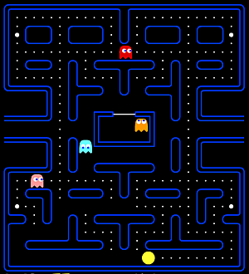
Simple Game
Start with a simple game that’s been around since almost the first graphical computer: PacMan™. Simply search the web for “online pacman” and you’ll uncover dozens of links to working versions. For our purposes, any of them will suffice.
Here are a few Flash versions:
http://www.thepcmanwebsite.com/media/pacman_flash/
http://www.learn4good.com/games/pacman/pacman.htm
http://www.webpacman.com/
The last link also includes several other vintage arcade games (e.g., Frogger™), and a History tab that may be interesting to some students.
For the iPad, there is a free version, PacMan-Lite:
https://itunes.apple.com/us/app/pac-man-lite/id293778748
Challenging Game
For a more modern and challenging game, we’ll use the popular AngryBirds™ (http://www.angrybirds.com/). Many of your students may be experts at this game. That’s great! After the novices are ready to give up on the entry-levels of the game, the experts can demonstrate and explain how to succeed at the advanced levels.
The Real Activity
The game play (and competition among students to get high scores) may seem to take center stage, but the educational goal of this activity is to identify aspects of adapting that are required in the game. For either game, one can learn the basics, employing basic eye-hand coordination, and enjoy the entry-level play. But advancement to the higher scoring levels requires adapting by learning new skills and strategies. What are those new skills and strategies? On the activity handout, ask students to list at least five new skills and five new strategies that are needed to advance in each game and to prepare to briefly discuss them. Challenge students to write down items that are not obvious.
Group Reflection Questions
This activity strives to demonstrate adaptation using a couple of simple video games. The early games like PacMan™ required minimal adapting, so students may even struggle to complete their list of five new skills and strategies. However, modern games like AngryBirds™ are very intricate and well-produced. They challenge gamers because they require a high level of adaptation of skills and strategies to advance and earn high scores.
In real life, there are yet many more facets of adaptation that will determine a person’s success. The message to take away from this activity is that to move beyond the beginning level of any task, successful people must adapt and learn new skills and strategies. Some players are able to adapt very readily; consequently, they will usually advance relatively quickly. Those that cannot adapt, or only with great effort, must be satisfied with the entry level of play for longer periods of time.
Discuss questions like the following with the class:
- Describe various ways you had to adapt to advance in PacMan™. In AngryBirds™. Did you find any clever tricks to use in the games?
- How is adaptability an important life skill?
- Consider an entry-level job at a fast-food restaurant. How might you be expected to adapt to advance up the ladder at that business? (Hint: contrast the job expectations of the entry-level worker with the shift supervisor.)
- Now consider an entry level job at _________ (insert an occupation linked to your course area). Again, how might you be expected to adapt to advance up the ladder in that field?
- What kinds of activities bridge the gap between entry-level employment and the next level?
Handout—“Adapting” in Video Games
Simple Game: (name of game)
How to score points:

New skills required to advance:

New strategies required to advance:

Complex Game: (name of game)
How to score points:

New skills required to advance:

New strategies required to advance:

Activity: Managing Stress
Instructor Preparation
Some workplace stress is normal, but excessive stress can interfere with ability to focus and be productive and impact physical and mental health. In this lesson students will explore stress, its causes, its effects on the individual, methods for reducing stress, and the concept of resilience.
To begin this module, have students discuss things that cause stress in their lives. Don’t discount any answers because factors affect individuals differently. Then focus the discussion on job stress. There might be generic stressors common to many jobs, such as a boss or coworker who is difficult to get along with, fear of a layoff, difficulty in meeting quotas, or a work space that is crowded, noisy, or otherwise less than satisfactory. Other jobs might be physically stressful, such as working outside and dealing with weather extremes, in dangerous environments, in enclosed spaces, on high rises, or in war zones. Discuss stress that might be career specific.
Accounting: Tax time is a very hectic time of year when an accountant is preparing numerous tax returns that benefit the customer and also must be accurate and follow the latest IRS guidelines.
Human Services: People who work with victims of abuse, whether child, spouse, or the elderly, need to be able to leave the situations they may be exposed to at work and not carry that burden when they are not at work. They need to focus on helping the client and not the terrible things that have happened to that person.
Public Safety: Emergency workers, police officers, and firefighters encounter periodic stress. Each time they are called out they may be walking into a crime in progress, a burning building that might include storage of flammable or explosive materials, a car wreck with injuries, or trapped people unable to help themselves—such as small children and babies, the elderly, or the infirm.
Wrap up the initial discussion of stress by asking students how they deal with stress or protect themselves from the effects of stress. Identify places in the community where people who are suffering from stress-related conditions such as anxiety, depression, or PTSD can get professional help. Remind students that this lesson is about awareness and examines normal workday stress; it is not as a lesson on the diagnosis and treatment of stress-related conditions. If anyone has deeper issues they need to seek professional help. Provide a resource list to all students.
Objectives
Students will:
- Identify stressors in their lives.
- Identify stressors that are job related.
- Identify ways to reduce stress and build resiliency.
Materials
- Computers with Internet access.
- Instructor-prepared list of local resources for dealing with stress-related conditions such as depression.
Activity Guidelines
Students should complete the Holmes and Rahe Stress Scale and the resiliency quiz individually to identify stress levels in their lives and determine how well they cope with stress.
- Have students take the Holmes and Rahe Stress Scale at http://www.mindtools.com/pages/article/newTCS_82.htm.
- Have students take the resiliency quiz at http://resiliencyquiz.com/index.shtml.
- Have students look at various websites that discuss ways of dealing with stress. Ask them to list things that reduce stress and increase resilience. Compile a class list. Ask students to mark things they already do, choose several things that they don’t do or could do better, and make a plan for incorporating at least one of those into their lives.
Group Reflection Questions
After students have had time to complete the stress and resiliency assessments individually, come together as a class and discuss the following questions.
- Scales like the Holmes and Rahe Stress Scale don’t include tragedies such as 9-11 destruction, the Boston Marathon bombings, massive accidents, natural disasters, and war. How would you rate them on the scale?
- Whom do you know that is a highly resilient person? Which characteristics of that person do you think make him or her more resilient?
- Why is resilience and the ability to handle stress needed for job success and fulfillment?
- What is the effect of employees with low resilience and high stress on the workplace as a whole?
- What are some things companies might do to help reduce stress for their employees?
- What are things you can do to reduce stress in your life?
Assessment Tools/Strategies
This section includes specific strategies and instruments for assessing students’ knowledge, skills, and attitudes in regard to the activities included in Adaptability and Lifelong Learning.
Rubrics
Rubrics are valuable assessment tools. Students should be provided with the rubric by which they will be assessed before an activity begins so they will understand the performance expectations. When time permits, students can contribute to the rubrics by brainstorming with the instructor about what a quality behavior or product looks like. For example, before assigning a team project to research a topic and prepare a group presentation, ask students to describe what behaviors the ideal team would demonstrate as they work together to complete the assignment and what elements need to be included in it. A rubric on adaptability might ask students to assess the degree to which they have researched a stress-relief concept and put it into practice. Prompt students with specific components. Then have them describe a poor performance. These will be the descriptions of the characteristics for the highest and lowest ends of the Likert scale for each performance criteria. Instructors should add any required attributes to the rubric if the students do not come up with them on their own. Rubrics for assessing student understanding of adaptability and lifelong learning are included in this section.
- The first rubric for instructor use lists desired attributes of Adaptability and Lifelong Learning to be observed and includes spaces where the instructor can adapt the rubric for a specific activity, project or career field by inserting additional criteria.
- The second and third rubrics are for self-rating use by students. The students indicate the degree to which they think they are performing each attribute. They can periodically return to the rubric to reassess and determine whether they are improving those skills.
- The final rubric is the most complex. The student completes a rubric by providing examples of satisfactory or exemplary performance of the tasks/behaviors listed. Then the student meets with the instructor or peer observer and compares his/her reflections with their instructor’s or peers’ observations and formulates an action plan for improving attitudes, behaviors, or skills.

This type of rubric most resembles the type of assessment an employee might receive on the job. It is also the most time consuming. Ideally, this rubric would be used at least three times during a course:
  - At the beginning of the course, to get a baseline and to give students suggestions for specific actions they might take to improve their performance,
  - At the midpoint of the course, to check progress and refine the recommendations for improvement, and
  - At the end of the course, to assess the progress made over the duration of the course. Additional suggestions can be made for students’ continued growth beyond the end of the course.
Rubrics for Instructor Assessment
Outcomes from Adaptability and Lifelong Learning – Successful workers in any career area must be able to adapt to changing workplace environments, skill requirements, and the interpersonal communication styles of fellow employees and supervisors. Any number of events may necessitate a career change, so workers in any career area must be alert to alternative career possibilities. Below are some outcomes to consider for this module. Feel free to edit this list to reflect course-related careers. The student is able to:
Complete a career-survey and identify at least three possible career matches. | 1 2 3 4 5
Enter the data to create a career genogram depicting at least two generations. | 1 2 3 4 5
Create a career path for a desired career cluster. | 1 2 3 4 5
Identify the requirements to advance from entry-level to a chosen career goal. | 1 2 3 4 5
List several alternative career paths that fit the student’s knowledge and skills. | 1 2 3 4 5
Identify several careers related to a specified career cluster. | 1 2 3 4 5
Identify the credentialing requirements, both general and specific, for one career. | 1 2 3 4 5
Distinguish between voluntary and mandatory credentialing requirements. | 1 2 3 4 5
Identify the professional organization(s) associated with a specified career area. | 1 2 3 4 5
Identify the continuing education requirements, if any, for maintaining certification or licensing in a given career. | 1 2 3 4 5
Identify the key publications and websites associated with a chosen career area (for the purpose of staying current in one’s field). | 1 2 3 4 5
Explain the connection (not necessarily a work-skill relationship) between a student’s choice of hobby and selected career area. | 1 2 3 4 5
List at least three skills or aptitudes that must be learned to participate in a chosen hobby. | 1 2 3 4 5
Describe or demonstrate the skills to advance past the entry-level of a computer game. | 1 2 3 4 5
Identify five significant stressors common in 1) daily life and 2) the workplace. | 1 2 3 4 5
List five strategies for reducing stress and building resiliency. | 1 2 3 4 5
 | 1 2 3 4 5

5 | Always | Excellent
4 | Most of the Time | Good
3 | Sometimes | Adequate
2 | Occasionally | Fair
1 | Never | Poor or None
Rubric for Self-Assessing Adaptability and Lifelong Learning Skills
Use this instrument throughout the course to self-monitor your adaptability and lifelong learning knowledge and skills. Note: It is fairly common to overrate your skills during the initial assessment. You may rate yourself a bit lower as you get feedback from others and discover the complexities of each attribute. By the end of the course you should see improvements in your ratings if you focus on improving the quality and depth of your work rather than primarily on getting the assignedment completed.
Objective: Your career choices should reflect your own personal skills and abilities.
Essential Attribute | I | II | III | IV
The results of my career survey match my personality, skills, and abilities. | Seldom | Sometimes | Usually | Consistently
I can see the impact of my family’s history and environments on my aptitudes, attitudes, and career choices. | Seldom | Sometimes | Usually | Consistently
I annually check my progress toward my career goals (education, skills training, certifications). | Seldom | Sometimes | Usually | Consistently
 | Seldom | Sometimes | Usually | Consistently

Objective: Your skills and abilities can change: they can deteriorate, improve, or expand.
Essential Attribute | I | II | III | IV
I am learning the skills needed to practice and be conversant in a certain hobby. | Seldom | Sometimes | Usually | Consistently
I am acquiring the tools and/or materials necessary for a certain hobby. | Seldom | Sometimes | Usually | Consistently
I am becoming more proficient and efficient in my work-related skills. | Seldom | Occasionally | Often | Consistently
I am applying strategies for reducing stress in my daily life and my work life. | Seldom | Sometimes | Usually | Consistently
I keep current in my field by reading, meetings, maintaining certifications, and supporting related organization(s). | Seldom | Sometimes | Usually | Consistently
 | Seldom | Sometimes | Usually | Consistently
Rubric for Assessing Adaptability and Lifelong Learning Skills
Outcome: A worker should consider his/her abilities and aptitudes to choose and maintain a career. In an ever-changing world, that means adapting to evolving technologies and resolving many sources of stress.
Performance Criteria
Reflection  Reflect on your actions during class or at a workplace and identify examples of when you: |  | Personal Plan  Based on your examples and the feedback of your instructor or peers, describe the steps you might take to continue or improve your adaptability and lifelong learning.
Used a career survey to consider career choices. | Example:  Peer / instructor review:  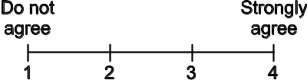 | Steps:
Applied a hobby-learned skill to the workplace or job training environment. | Example:  Peer / instructor review: | Steps:
Over time, demonstrated improvements in proficiency and efficiency with career-related skills. | Example:  Peer / instructor review: | Steps:
Sought help in learning a new skill. | Example:  Peer / instructor review: | Steps:
Volunteered to assist or comfort an overwhelmed coworker or supervisor. | Example:  Peer / instructor review: | Steps:

Peer comments and suggestions:
Instructor comments:

Videos and Weblinks
Videos
The following is an annotated list of videos that are available at the links provided. You may choose to use these in class to give additional background on Adapting and Lifelong Learning, as discussion starters, or as examples of effective or ineffective communications.
https://www.youtube.com/watch?v=Zy6YoyTcwUw (14:33)
Thinking Forward: Adapting to a Changing Workplace, presentation by Bill Self.
Discusses adapting to address customer satisfaction.
http://www.careeronestop.org/Videos/default.aspx
U. S. Department of Labor supported website, with over 500 short videos that explore popular occupations across all 16 career clusters.
Weblinks
Here are some links relevant to this module that may be useful.
http://www.mapyourcareer.org/construction/construction-careers.html
Career Paths in Construction
http://www.nc-net.info/clusters_guide/career_exploration_section.pdf
Printable document that includes a career clusters survey and several valuable links for further information, as compiled by the North Carolina Department of Public Instruction (NCDPI) and the North Carolina Community College System (NCCCS).
http://www.careeronestop.org/
Career exploration website sponsored b y U. S. Department of Labor. Includes career survey instruments and short videos that explore popular careers in each of the career-clusters.
http://www.iseek.org/careers/clusterSurvey
Online career survey from Oklahoma Department of Career and Technical Education.
https://www.okcareertech.org/students/career-resources/job-seeking-resources/self-assessment-and-interest-inventories
Printable survey instrument to identify one’s aptitude for a career cluster.
http://www.123test.com/career-test/
A visual-aptitude test, where one selects the most preferred and least preferred activity, based on sketches of career-related activities, derived from Dr. John Holland's theory of careers and vocational choice, known as Holland Codes.
http://www.military.com/join-armed-forces/asvab
The Armed Services Vocational Aptitude Battery (ASVAB) is a timed multi-aptitude test, given at over 14,000 schools and Military Entrance Processing Stations (MEPS) nationwide and is developed and maintained by the Department of Defense. The ASVAB can provide career information for either civilian or military occupations, and is an indicator for success in future endeavors whether one chooses to go to college, vocational school, or a military career.
http://www.myheritage.com/
Create a family tree using this free online tool. One can use this activity to help document the careers of family members: a career genogram.
http://www.genopro.com/genogram/rules/
Illustrated Genogram rules, although this gets pretty deep into some obscure possibilities.
http://www.acinet.org/certifications_new/
Certifications are examinations that test or enhance knowledge, experience, or skills in an occupation or profession. Search for certifications by keyword, industry, or occupation.
http://www.cacareercafe.com/
Designed to assist California Community College students to plan their careers, this site provides assessments, weblinks, and other information to guide students in career planning. Much of the information is generic, but job banks and some other information is California specific.
http://www.careerbuilder.com/
Provides career advice to job seekers and tools to match the right talent with the right opportunity.
http://www.mindtools.com/index.html
Resources to help in any career. The toolkit is particularly valuable. Contains numerous free articles and quizzes to make it worth a visit.
http://www.myskillsmyfuture.org/
Search for related careers using skills only or skills with job tasks.

